**Blog Submission**

**Project-1**

**Customer Churn Analysis**



*This is my first machine learning project. Recently I have completed this project. I am here to describe how i solved the case study in a very detailed manner.*

**Submitted by: Krishna Prasad**

**Acknowledgement**

*Many thanks to Data Trained for providing me this project to understand about the Real Time Field work present in Data Science Industry.*

*As this project of Churn Prediction was very sufficient and preferable for me to acknowledge about the live customer churned out due to various use of Social Networking Platforms in ultimate users which predict the telecom industries.*



**Contents**

1. [**Introduction**](https://towardsdatascience.com/building-an-employee-churn-model-in-python-to-develop-a-strategic-retention-plan-57d5bd882c2d#c099)
2. **Work Steps**
3. [**EDA**](https://towardsdatascience.com/building-an-employee-churn-model-in-python-to-develop-a-strategic-retention-plan-57d5bd882c2d#030a)

1. **[Building Machine Learning Models](https://towardsdatascience.com/building-an-employee-churn-model-in-python-to-develop-a-strategic-retention-plan-57d5bd882c2d" \l "8341)**
2. **[Conclusion](https://towardsdatascience.com/building-an-employee-churn-model-in-python-to-develop-a-strategic-retention-plan-57d5bd882c2d" \l "13e2)**

**1.Introduction**

*Customer churn is when a company’s customers stop doing business with that company. Businesses are very keen on measuring churn because keeping an existing customer is far less expensive than acquiring a new customer. New business involves working leads through a sales funnel, using marketing and sales budgets to gain additional customers. Existing customers will often have a higher volume of service consumption and can generate additional customer referrals.* ***Churning****in****Telecom****industry is the percentage of subscribers moving from a specific service or a service provider to another in a given period of time.**Churning is also referred as customer turnover. Churn has a huge impact on profits and reputation of the company.*

**What exactly is Churn Prediction?**  *Churn is defined in business terms as ‘when a client cancels a subscription to a service they have been using.’ So, Churn Prediction is essentially predicting which clients are most likely to cancel a subscription that is ‘leave a company’ based on their usage of the service. From a company point of view, it is necessary to gain this information because acquiring new customers is often arduous and costlier than retaining old ones. Hence, the insights gained from Churn Prediction helps them to focus more on the customers that are at a high risk of leaving.*

***Why does Churn occur?*** *Many factors influence the reasons for a customer to Churn. It may be the fact that there’s a new competitor in the market offering better prices or maybe the service they are getting has not been up to the mark, so on and so forth.*

**Catching customers before they churn** *Although, there are many factors for customer churn, preventing it is usually straightforward. It depends on the fact that how the company makes the clients feel special and provide a sort of customized experience to convince them to stay.*

**2.Work Steps**

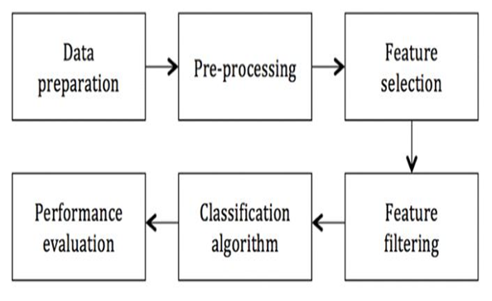

**Target Variable(Label):**

Churn is the target variable which specifies if a customer has stop doing the business with that company or not.



**Columns:**

1.CustomerID: The unique ID of each customer.

2.Gender: The gender of a person.

3.SeniorCitizen: Whether a customer can be classified as a senior citizen.

4.Partner: If a customer is married/ in a live-in relationship.

5.Dependents: If a customer has dependents (children/ retired parents).

6.Tenure: The time for which a customer has been using the service.

7.PhoneService: Whether a customer has a landline phone service along with the internet service.

8.MultipleLines: Whether a customer has multiple lines of internet connectivity.

9.InternetService: The type of internet services chosen by the customer.

10.OnlineSecurity: Specifies if a customer has online security.

11.OnlineBackup: Specifies if a customer has online backup.

12.DeviceProtection: Specifies if a customer has opted for device protection.

13.TechSupport: Whether a customer has opted for tech support of not.

14.StreamingTV: Whether a customer has an option of TV streaming.

15.StreamingMovies: Whether a customer has an option of Movie streaming.

16.Contract: The type of contract a customer has chosen.

17.PaperlessBilling: Whether a customer has opted for paperless billing.

18.PaymentMethod: Specifies the method by which bills are paid.

19.MonthlyCharges: Specifies the money paid by a customer each month.

20.TotalCharges: The total money paid by the customer to the company.

21.Churn: This is the target variable which specifies if a customer has churned or not.

**Problem description:**

***The goal is to predict churn which means whether the customers has stop doing the business with that company or not.***

**Importing Libraries:**

*I am importing all the library which I required for EDA, visualization, prediction and finding all matrices. The reason of doing this is that it become easier to use all the import statement at one go and we do not require to import the statement again at each point.*

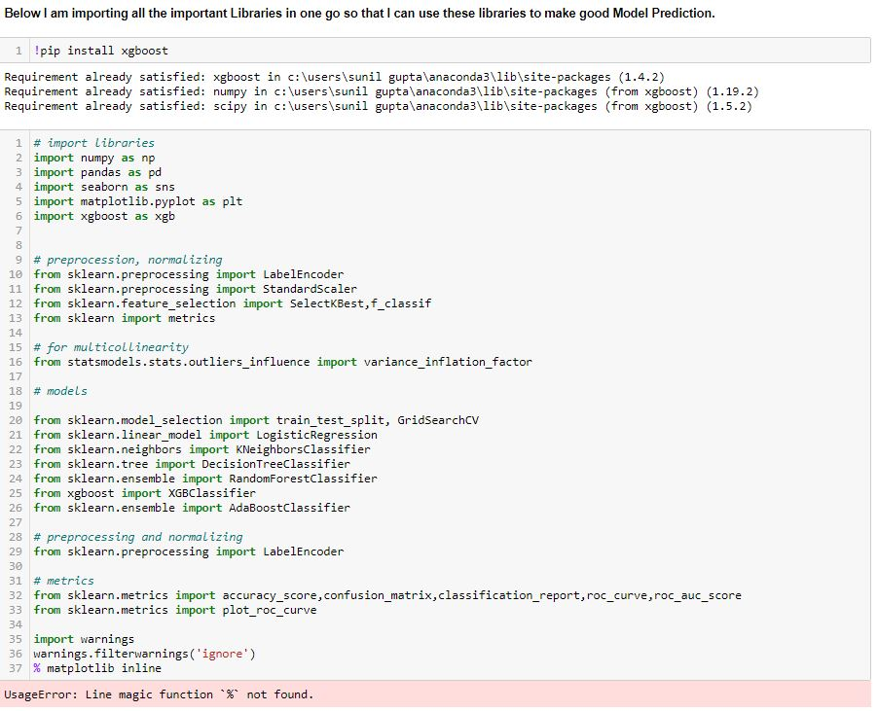

**Loading Data Set into variable:**

*Here I am loading the data set into a variable i.e. “df” and processing the first 5 rows.*

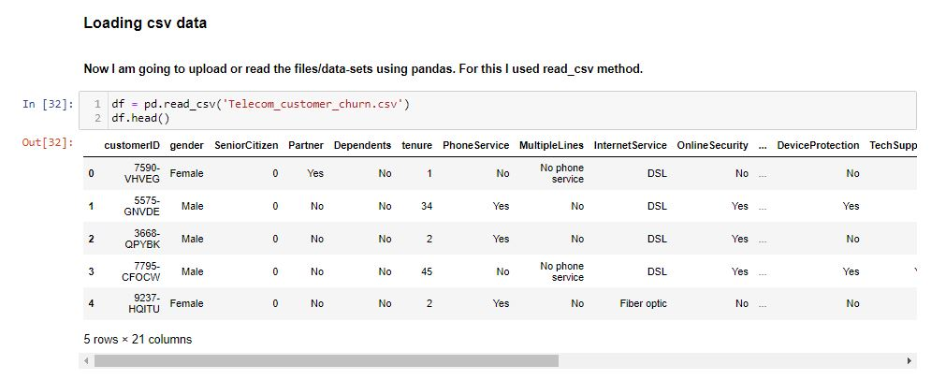**3.Exploratory Data Analysis:**

*Before you start a machine learning project, its important to ensure that the data is ready for modelling work. Exploratory Data Analysis (EDA) ensures the readiness of the data for Machine Learning. In fact, EDA is primarily used to see what data can reveal beyond the formal modelling or hypothesis testing task and provides a provides a better understanding of data set variables and the relationships between them. So in this dataset I have used various EDA Techniques to analyse a data in a proper way.*

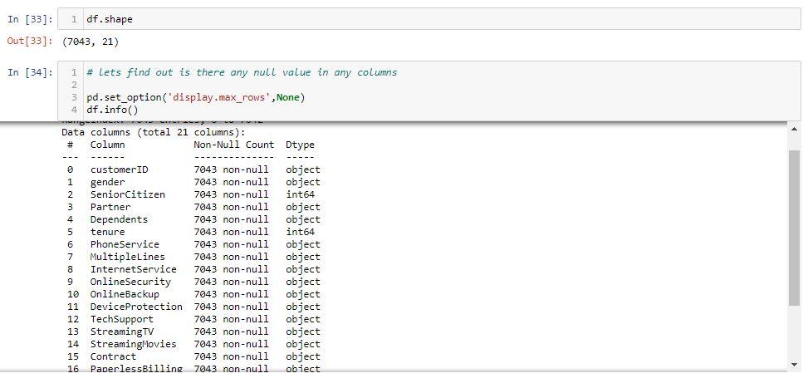

#### Well as a first observation I can see that there are no missing values in the above dataset. According to the shape of the dataset it contains 7043 rows & 21 columns.

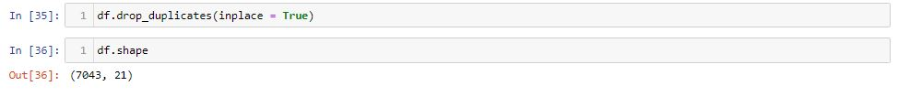

#### There are no duplicates in this dataset.

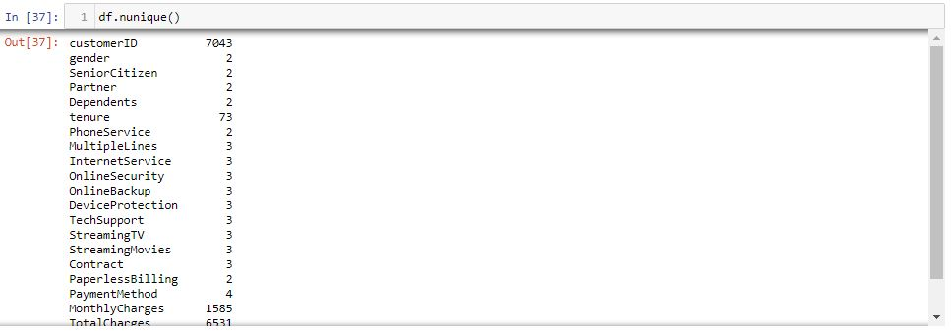

#### *By finding (df.unique()) it distinguish the difference between continuous & categorical columns in this dataset. Most of the columns are categorical in nature.*

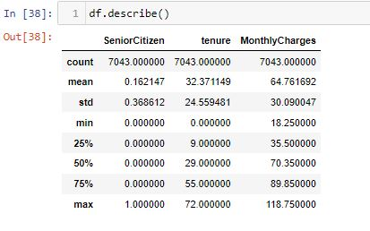

#### Above statistics data show that there are no outliers in this dataset. There is also difference between mean and 50% value in some of the columns which used to get fix for better prediction.

*Count rows numbers for each column are same so there is no missing values or null values.*

**Count Plot & Pie Plot Definition**

**Count Plot**

*Count Plot function is used for visualizing data of a machine learning and data science project. The Count Plot is majorly used for showing the observational count in different category-based bins with the help of bars.*

**Pie Plot**

*A pie chart is a way of summarizing a set of categorical data or displaying the different values of a given variable. This type of chart is a circle divided into a series of segments. Each segment represents a particular category.*

**Gender**

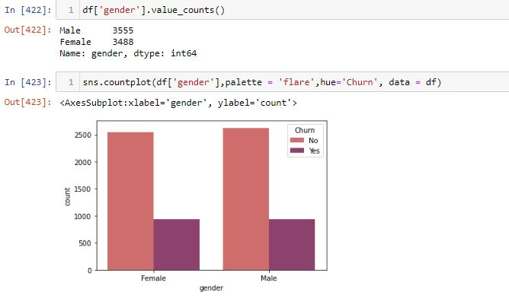

#### According to the Count Plot of "gender" column i can see "Male" customers are churned out highly. "Female" customers are less churned.

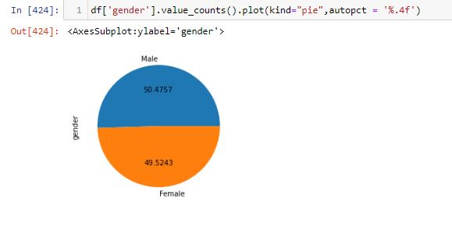

#### As I can see, about 50.47%('Male') of the customers have churned out. Rest 40.52%('Female') have stayed with the company.

**Senior Citizen**

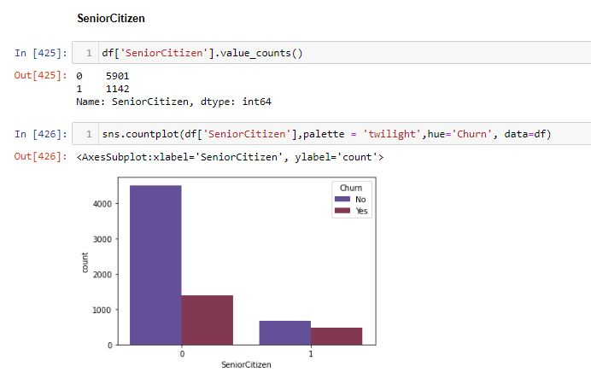

*I can say that ratio of churn vs not churn 1:3. So out of every 4 customer 1 customer is stop doing the business with existing company.*

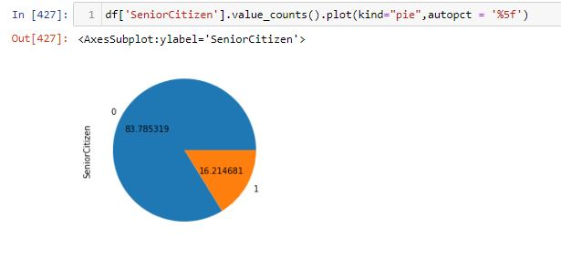*I can say that approx. 16.21 senior citizen customer prefer to leave the existing business service provider.*

**Partner**

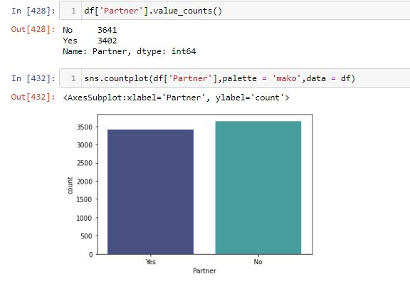

*The above graph say that I hardly matter whether you are single or married.*

**Dependents**

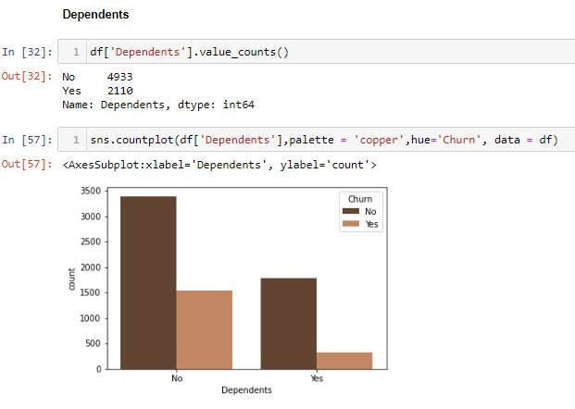

*The non-dependent customers are more likely to leave the company than dependent customers.*

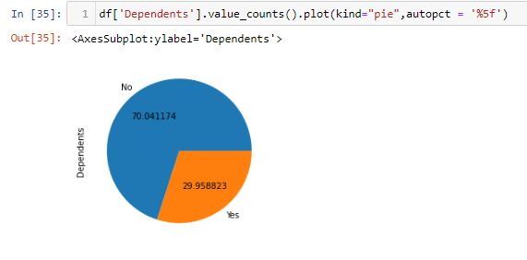

*I can say that around 70.04% are non-dependent and 29.95% customers are dependent.*

**Phone service**

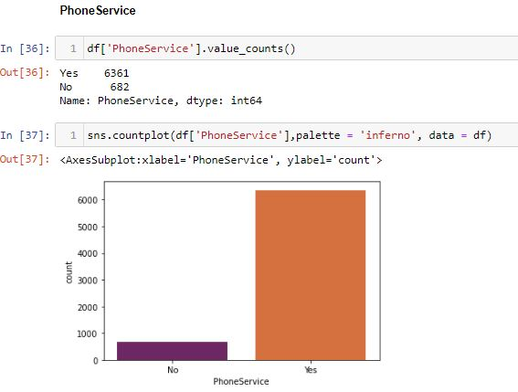

#### ‘Yes'(6361) signifies most of the customers has a landline phone service along with the internet service. 'No'(682) tells those customers doesn’t use Phone Service.

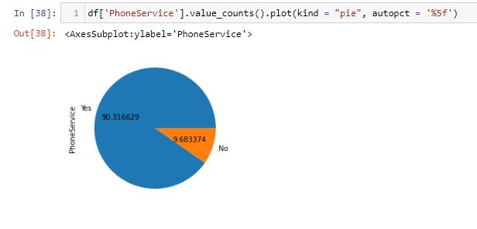

#### From the above pie plot speaks 'Yes' with 90.31% customers uses Phone Service and the rest 9.68% doesn’t use services.

**Multiple Lines**

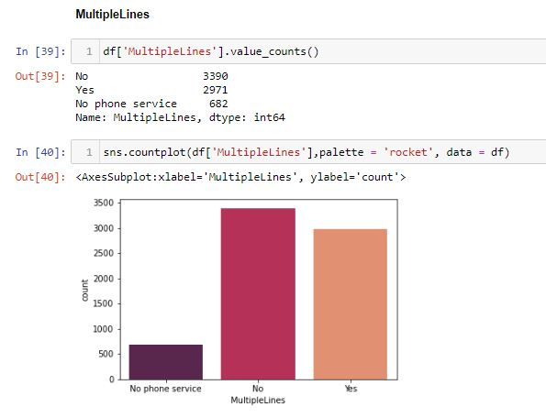

#### 'No' tells 3390 customers have one line of internet connectivity,’ Yes' shows 2971 customers have more than one internet connectivity and 'No Phone Service' speaks these customers are not interested in any internet service.

*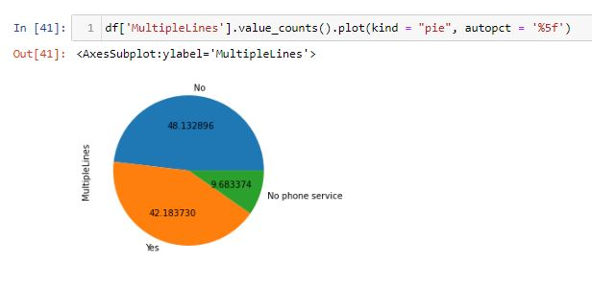 I can say that 42.18% customers have multiple lines , 48.13% have single line and 9.68% have no phone services.*

**Internet Service**

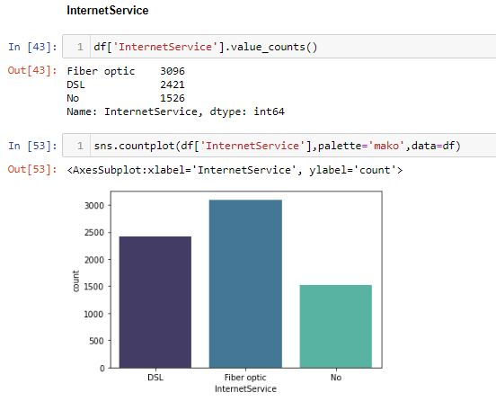

#### 3096 of the customers uses Fibre optic Internet service to get smooth consumption of internet. 2421 customers consumes DSL internet service and 1526 uses no internet services.

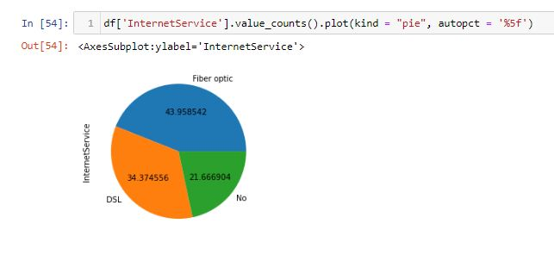*Fibre optic with 43.95% are been used by wide range of customers to obtain smooth internet service.*

**Online Security**

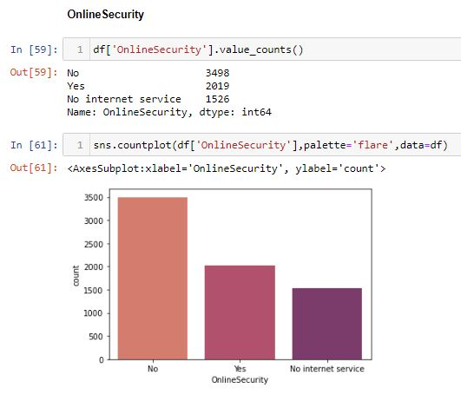

#### From the above plot i can say 3498 customers uses internet without security and through which this causes several cyber attacks to the internet users. ‘Yes' shows 2019 customers are very much conscious about the security. ‘No internet service tells' 1526 customers are inactive in using internet service.

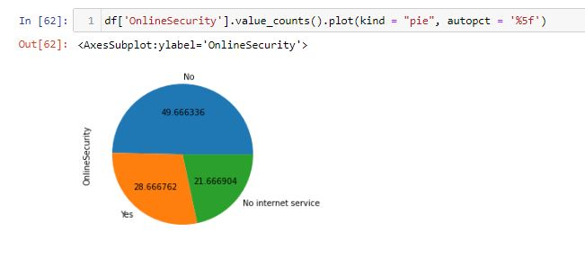

*Approx. 49.66% customers uses internet services without security which leads to cyber attacks.*

**Online Backup**

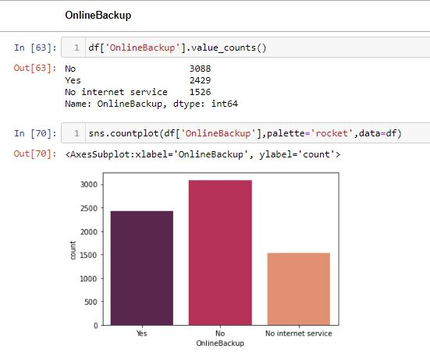

#### 3088 customers has no online backup.2429 customers have online backup for having all time internet connectivity. While 1526 customers doesn’t have internet connection.

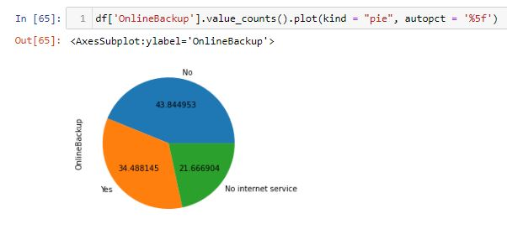*43.84% customers doesn’t have online backup which causes them problem in using internet as they are dependent only on one source.*

**Device Protection**

**Device Protection**

#### 

#### Protection is a secret of been safe & secure for using internet service, but according to this count plot I can see 3095 customers has not opted device protection security.

#### 2422 customers have opted device protection which shows they are very much safe of using internet service. At the end 1526 customers are having no internet service.

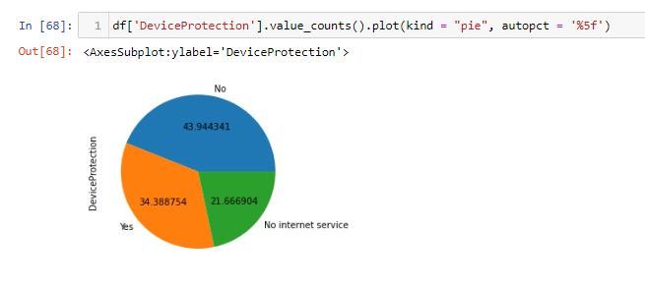

*With the help of pie plot i can see 43.94% customers has no device protection which specify they are carelessly using internet service without any fear of cyber attacks. Along with this 34.38% customers are conscious about there device protection and 21.66% customers have no role in internet service.*

**Tech Support**

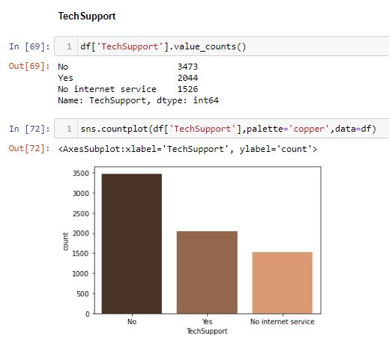

#### 3473 customers has not opted for tech support which shows how much they are careless about Internet service.2044 customer has received tech support which says they got the backup from the company and 1526 never taken internet connection so they are unable to opt Tech support..

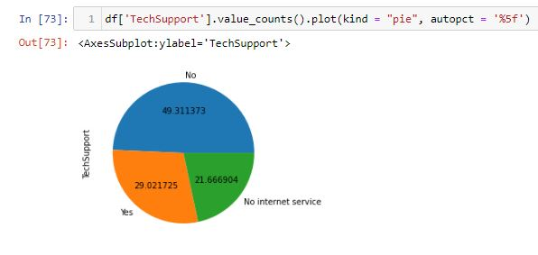

*49.31% customer didn’t opt for tech support on the other hand 29.02% opt for tech service.*

**Streaming TV**

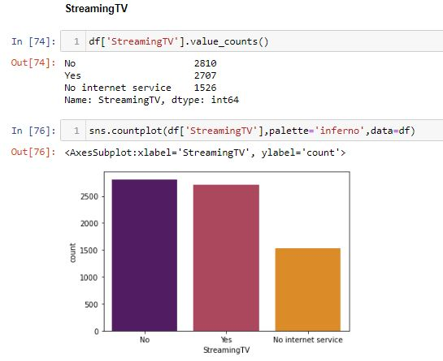

#### 2707 customers has an option of TV streaming through internet service.2810 customers deny to choose the option of Streaming TV and 1526 customers has no internet service.

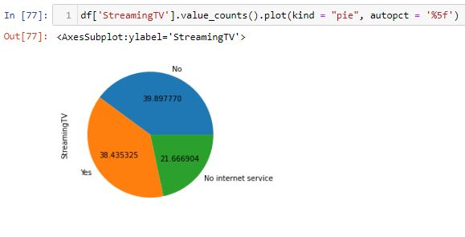*After choosing internet service 38.43% has taken streaming TV option with internet connectivity. While 39.89% have not taken TV option in internet package and 21.66% has no internet connection.*

**Streaming Movies**

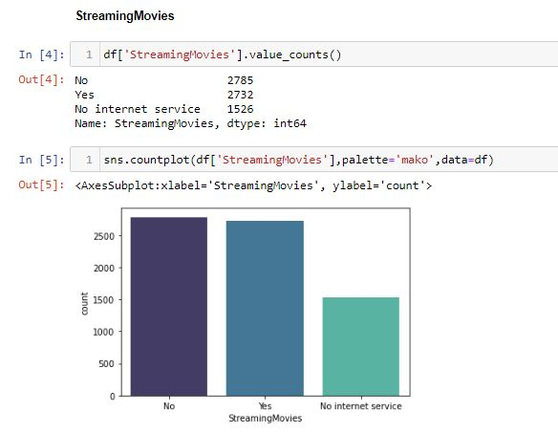

#### 2732 customers has an option of Streaming Movies in internet service.2785 customers deny to choose the option of Streaming Movies and 1526 customers has no internet service.

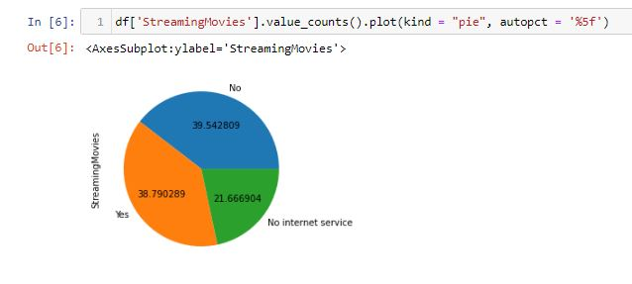

*After choosing internet service 38.79% has taken Streaming Movies option with internet connectivity. While 39.54% have not taken Streaming Movies option in there subjective internet package and 21.66% has no internet connection.*

**Contract**

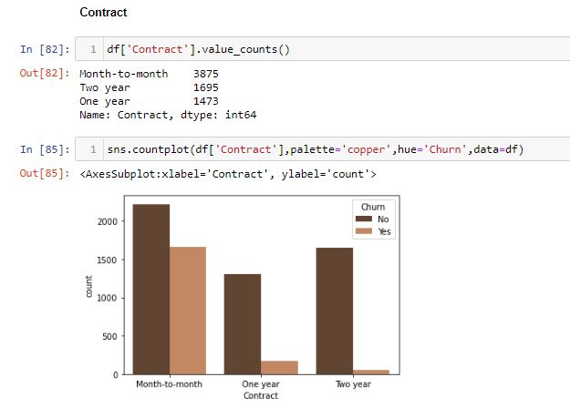

#### Contract of a internet connection binds customers not to switch to another internet service company. Those customers who are in one year or two years contract are not getting churned.

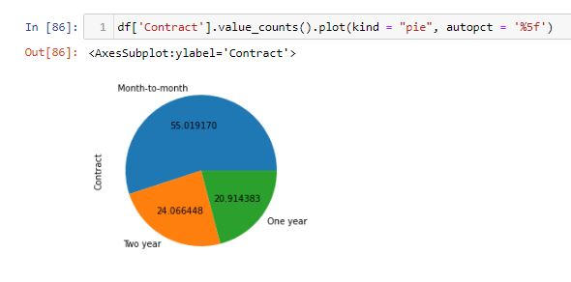*According to these pie plot i can see 55.01% customers are not in contract with there internet service provider.*

**Paperless Billing**

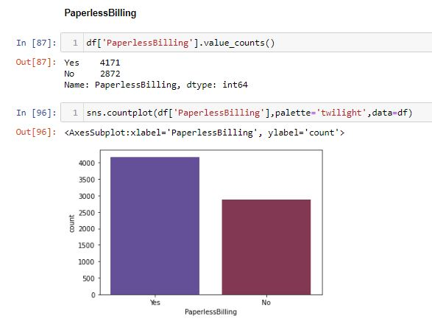

#### After taking subscription of internet service every customers should receive payment receipt through billing method. As this plot shows 4171 customers has opted internet service billing receipt. While, 2872 customers has not taken the receipt bill.

**Payment Method**

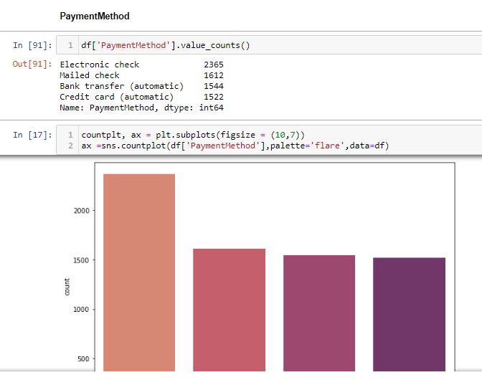

#### Electronic check customers(2365) are the highest in paying bills for internet service. Then comes Mailed Check customers (1612) are the second highest paying bills customers for Internet connection. Payment method through Bank transfer (automatic) are (1544) customers and at last credit card payment method are used by (1522) customers.

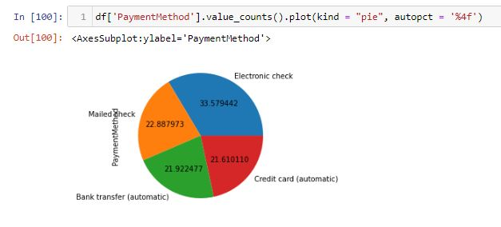

*As I can see through Pie plot that Electronic check payment method is widely used with 33.57% and rest are using Mailed check, Bank transfer (automatic),Credit card (automatic) with 22.88%,21.92%, & 21.61% for bill payments.*

**Churn**

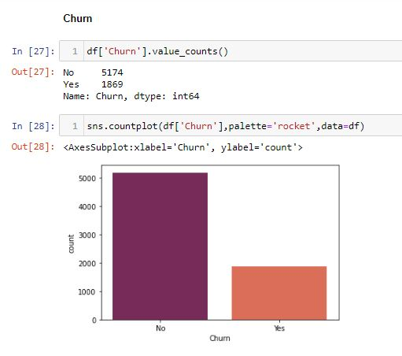

#### 5174 customers has stayed in the company while 1869 customers had leaved the company.

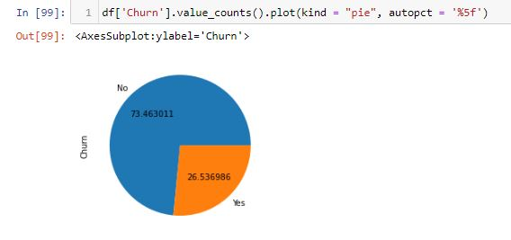

#### 73.46% of customers are staying and the rest 26.53% customers are leaving the company.

#### **Dropping unwanted columns**

#### 

#### I have dropped the Un-Wanted columns and use head() & shape code to get the summary of dataset after Data Visualization.

**Label Encoding**

*This approach is very simple and it involves converting each value in a column to a number. Hereby, I would focus on Label-Encoder. So it is used as a part of SciKit-learn library (one of the most widely used Python library) and are used to convert text or categorical data into numerical data which the model expects and perform better with.*

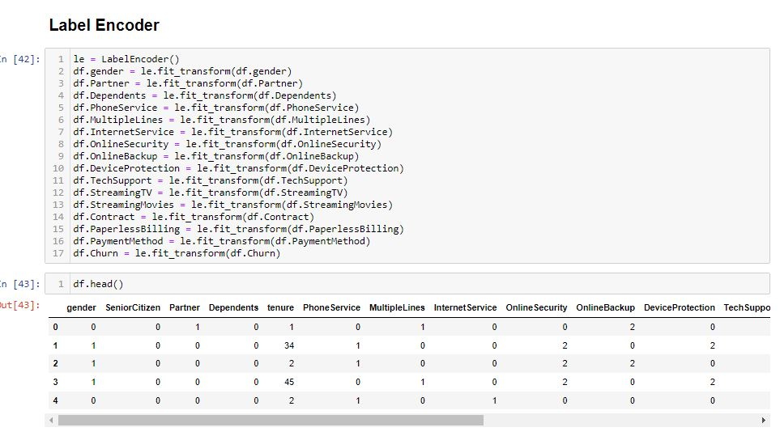

#### After Applying Label Encoder i have converted all the strings columns into integer.

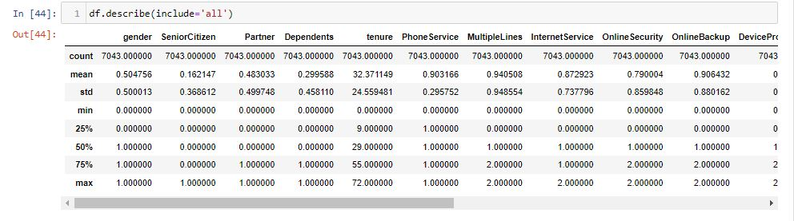

*From the describe code i can say that there are few zero values in this dataset which i will replace soon.*

**Distribution Plot**  
*It is used basically for univariate set of observations and visualizes it through a histogram that is only one observation and hence we choose one particular column of the dataset.*

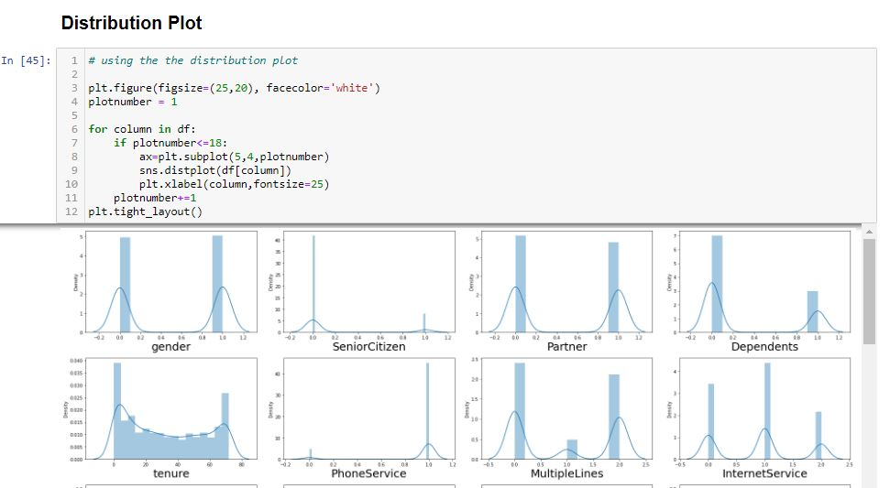

#### After replacing categorical columns to numerical values I use Distribution Plot to find the Skewness in this Dataset which I will remove soon.

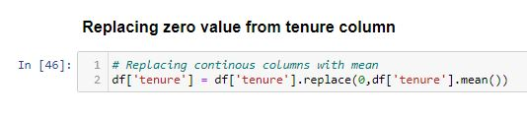

*According to the Dataset (tenure) column have zero values and also of continuous type which i have replace it with the help of mean.*

#### **Box Plot**

#### T**hi**s the visual representation of the depicting groups of numerical data through their quartiles. **Boxplot** is also used for detect the outlier in data set.

*I used box plot in this dataset because It captures the summary of the data efficiently with a simple box and whiskers and allows me to compare easily across groups.*

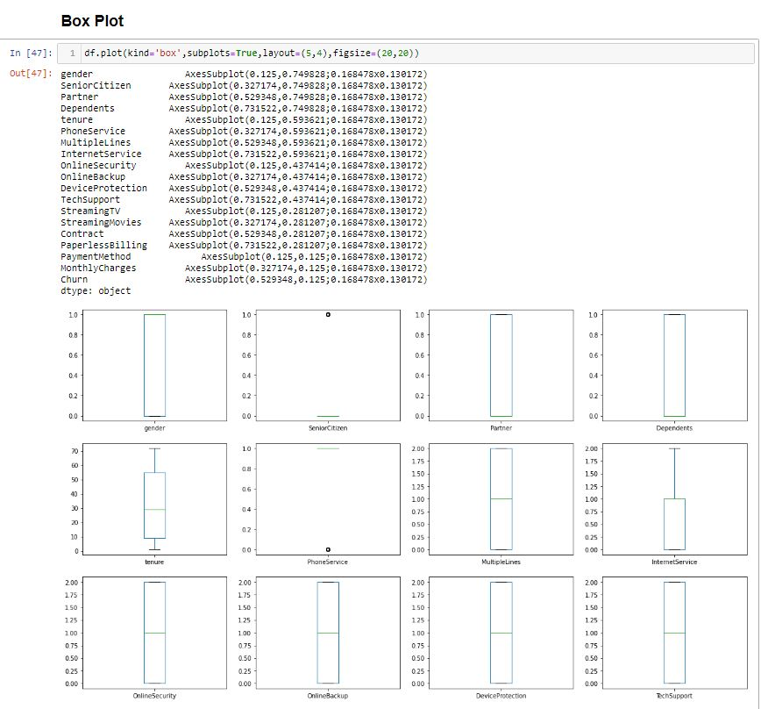

*The dataset seems to be clean as there are no outliers in any column.*

[**4.Building Machine Learning Models**](https://towardsdatascience.com/building-an-employee-churn-model-in-python-to-develop-a-strategic-retention-plan-57d5bd882c2d#8341)

*Here’s the role of the label that comes into existence. A label is given to such features to distinguish them from other features. Thus, I have obtain labels as output when provided with features as input.*

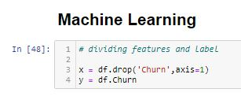

*Dividing the features and label into x and y.*

**STANDARD SCALER**

*In Machine Learning, Standard Scaler is used to resize the distribution of values ​​so that the mean of the observed values ​​is 0 and the standard deviation is 1.*

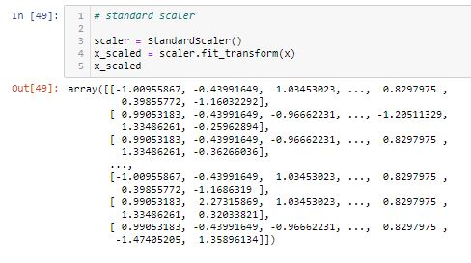

#### By using standard scaler I have scaled the data in one range.

**VIF – VARIANCE INFLATION FACTOR**

*VIF is preferred as it can ‘****show the correlation of a variable with a group of other variables’****. Dropping one of the correlated features will help in bringing down the multicollinearity between correlated features: The image contains the original VIF value for the dataset.*

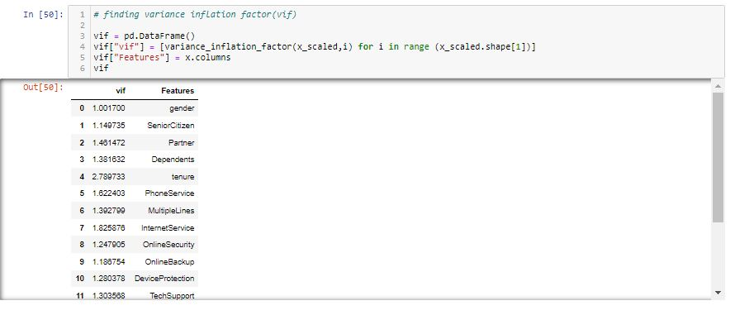

# *VIF score for all the columns is below 5 which means* *Multicollinearity doesn’t exist.*

# Train Test Split

# *The train-test split procedure is used to estimate the performance of machine learning algorithms when they are used to make predictions on data not used to train the model.*

# *I used train test split as it is a fast and easy procedure to perform, the results of which allow me to compare the performance of machine learning algorithms for my predictive modelling problem.*

# 

#### Therefore I have split the dataset into training and testing. I have used 25% of data for testing and 75% of the dataset for training. I used random state for consistent result.

**LOGISTIC REGRESSION**

*Logistic regression is a supervised learning classification algorithm used to predict the probability of a target variable. The nature of target or dependent variable is discontinuous, which means there would be only two possible classes.*

*Generally, logistic regression means binary logistic regression having binary target variables, but there can be two more categories of target variables that can be predicted by it.*

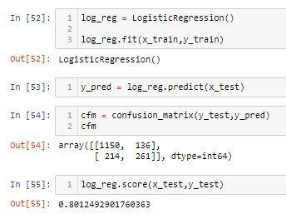

### *By using Logistic Regression I Get Accuracy Score : 80.12%*

**Auc Score**  *The AUC for the ROC can be calculated using the roc_auc_score() function , the AUC function takes both the true outcomes (0,1) from the test set and the predicted probabilities for the 1 class. It returns the AUC score between 0.0 and 1.0 for no skill and perfect skill respectively.*

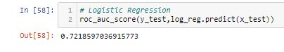

#### So, I get Auc Score from Logistic Regression is 72.18%.

**Features Selection Method**

*Feature Selection is one of the core concepts in machine learning which hugely impacts the performance of your model. The data features that you use to train your machine learning models have a huge influence on the performance you can achieve.*

*Irrelevant or partially relevant features can negatively impact model performance.*

*Feature selection and Data cleaning should be the first and most important step of your model designing. Therefore, I used Select K Best Method for best features selection.*

### **Using Select K Best Method for best features selection**

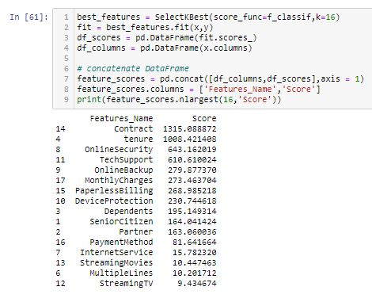

*I have used best 16 features in KNN method. Out of which I got "Contract” plays a important role in Churn Prediction.*

**KNN - K-Nearest Neighbour**

*It is a supervised machine learning algorithm. The algorithm can be used to solve both classification and regression problem statements. The KNN algorithm can compete with the most accurate models because it makes highly accurate predictions. Therefore, you can use the KNN algorithm for applications that require high accuracy but that do not require a human-readable model. The quality of the predictions depends on the distance measure.*

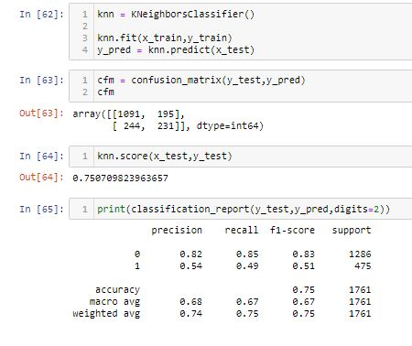

### By using KNN I Get Accuracy Score : 75.07%

### **Let use Grid search CV for the best parameter to improve the accuracy** *GridSearchCV is a library function that is a member of sklearn's model_selection package. It helps to loop through predefined hyperparameters and fit your estimator (model) on your training set. So, in the end, you can select the best parameters from the listed hyperparameters.**So**I used Grid search CV to choose the best parameters in this knn algorithm*

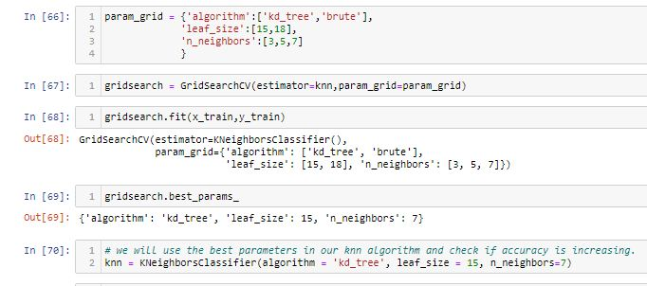

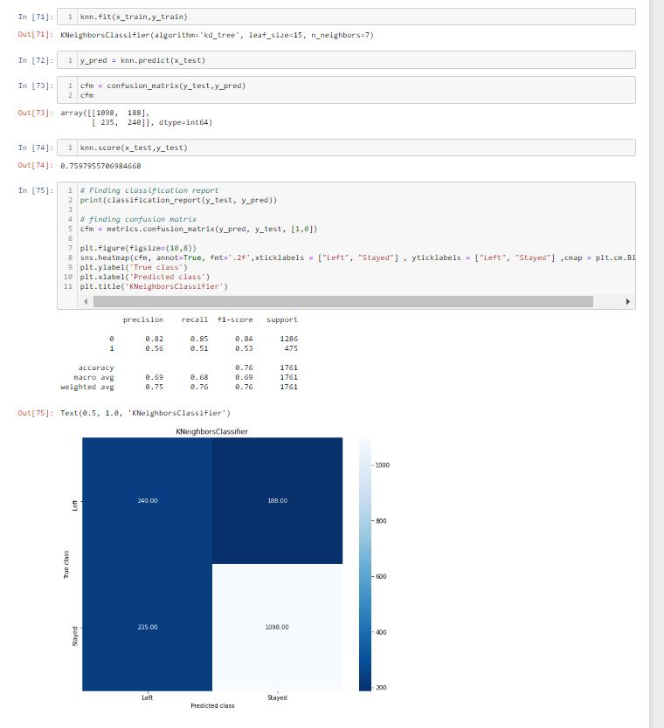

**By using Grid search CV in KNN I improve Accuracy Score : 76%**

**Roc Auc Score** *The AUC for the ROC can be calculated using the roc_auc_score() function , the AUC function takes both the true outcomes (0,1) from the test set and the predicted probabilities for the 1 class. It returns the AUC score between 0.0 and 1.0 for no skill and perfect skill respectively.*

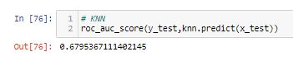

#### So, I get Auc Score from KNN is 67.95%.

## **Random Forest Classifier**

A random forest is a machine learning technique that's used to solve regression and classification problems. It utilizes ensemble learning, which is a technique that combines many classifiers to provide solutions to complex problems. So random forest is the 3rd algorithm which I am using for predicting churn.

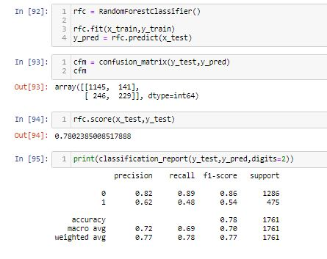

### *By using Random Forest Classifier I Get Accuracy Score : 78.02%*

### **Let use Grid search CV for the best parameter to improve the accuracy**

*GridSearchCV is a library function that is a member of sklearn's model_selection package. It helps to loop through predefined hyperparameters and fit your estimator (model) on your training set. So**I used Grid search CV to choose the best parameters in this random forest algorithm.*

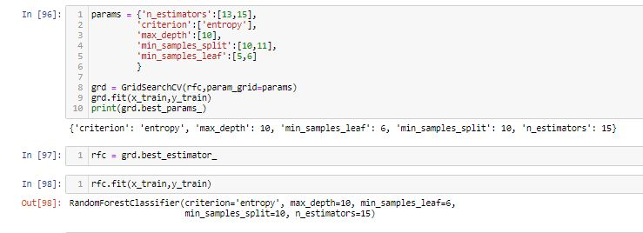

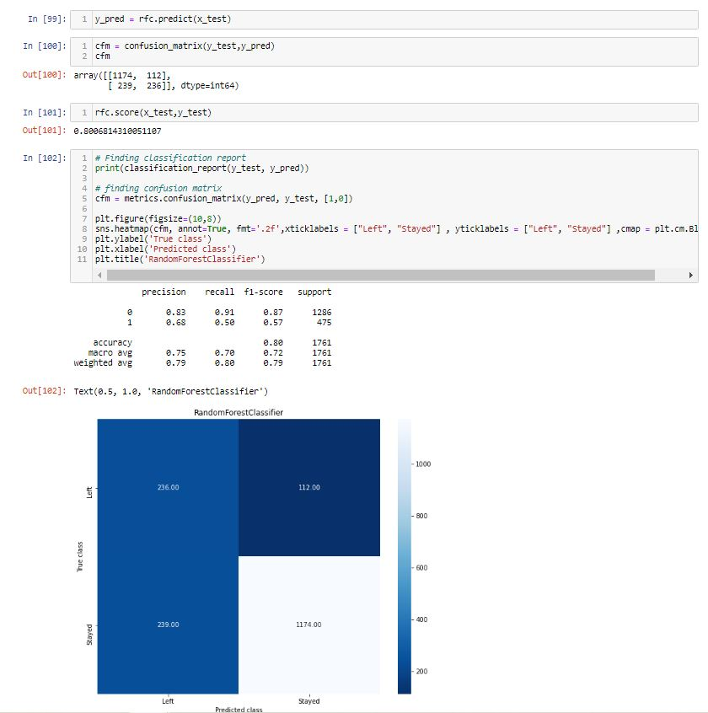**By using Grid search CV in random forest I improve Accuracy Score to 80.06%**

**Roc Auc Score** *The AUC for the ROC can be calculated using the roc_auc_score() function , the AUC function takes both the true outcomes (0,1) from the test set and the predicted probabilities for the 1 class. It returns the AUC score between 0.0 and 1.0 for no skill and perfect skill respectively.*

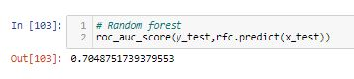

#### So, I get Auc Score from Random Forest classifier is 70.48%

**Decision Tree Classifier**

*Decision tree is one of the predictive modelling approaches used in Machine Learning. It is one of the most widely used and practical methods for supervised learning. The decision tree Algorithm belongs to the family of supervised machine learning algorithms. It can be used for both a classification problem as well as for regression problem. Therefore, Decision tree is the 4th Algorithm used by me.*

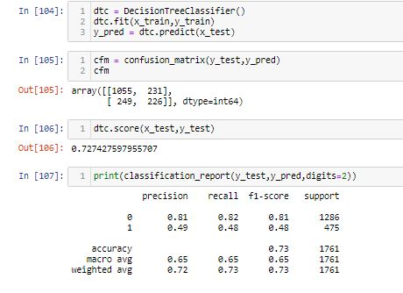

*By using Decision Tree Classifier I Get Accuracy Score : 72.74%. Now I have to improve the accuracy score by using best hyperparameters.*

### **Let use Grid search CV for the best parameter to improve the accuracy.**

*GridSearchCV is a library function that is a member of sklearn's model_selection package. It helps to loop through predefined hyperparameters and fit your estimator (model) on your training set. So I used Grid search CV to choose the best parameters in this Decision tree algorithm.*

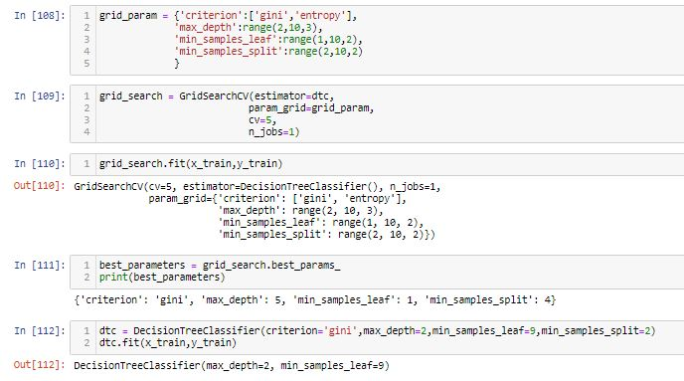

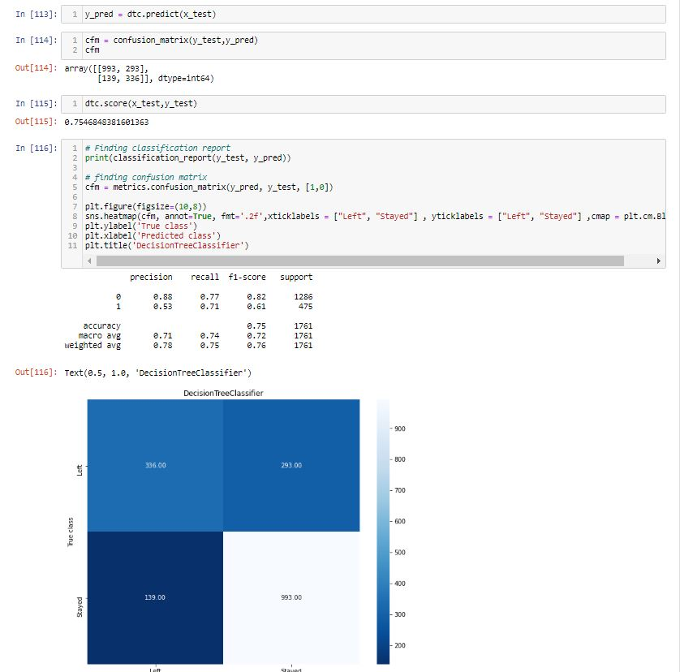

**By using Grid search CV in Decision tree I improve Accuracy Score to 75.46%**

**Roc Auc Score in Decision tree Classifier** *The AUC for the ROC can be calculated using the roc_auc_score() function , the AUC function takes both the true outcomes (0,1) from the test set and the predicted probabilities for the 1 class. It returns the AUC score between 0.0 and 1.0 for no skill and perfect skill respectively.*

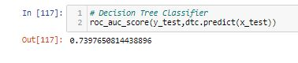

#### So, I get Auc Score from Decision Tree classifier is 70.48%

**XGB CLASSIFIER**

*XGBoost stands for “Extreme Gradient Boosting”, is one of the well-known*[*gradient boosting*](https://analyticsindiamag.com/gradient-descent-everything-you-need-to-know-with-implementation-in-python/)*techniques having enhanced performance and speed in tree-based machine learning algorithms. It is an implementation of gradient boosted decision trees designed for speed and performance. Therefore, I have used Extreme Gradient Boosting as 5th algorithm in this project.*

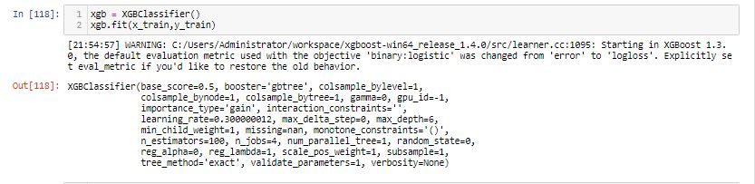  
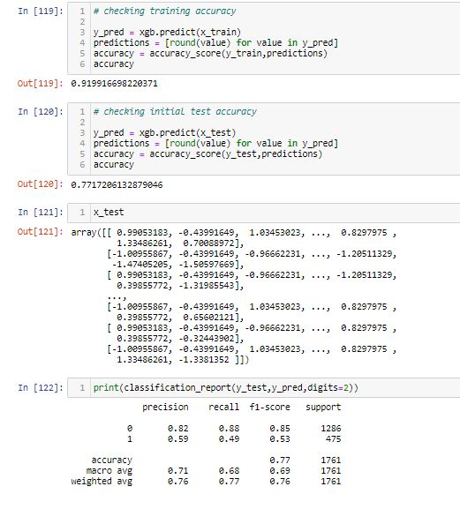

By using XGB Classifier I Get Accuracy Score : 77.17%.Now I will go to improve the accuracy score by using best hyperparameters.

### **Let use Grid search CV for the best parameter to improve the accuracy.**

*GridSearchCV is a library function that is a member of sklearn's model_selection package. It helps to loop through predefined hyperparameters and fit your estimator (model) on your training set. So I used Grid search CV to choose the best parameters in this XGBoost Classifier algorithm.*

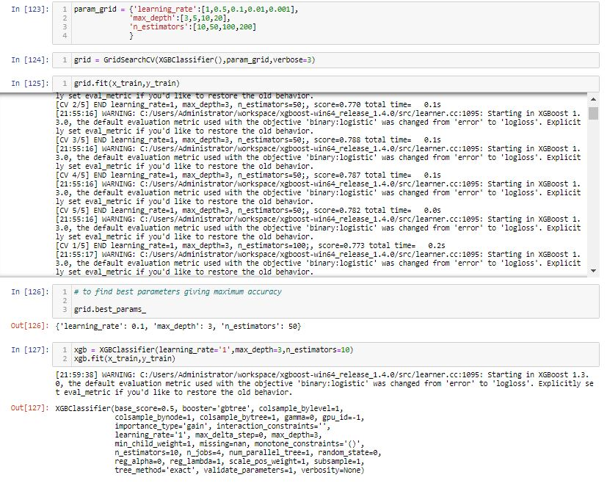

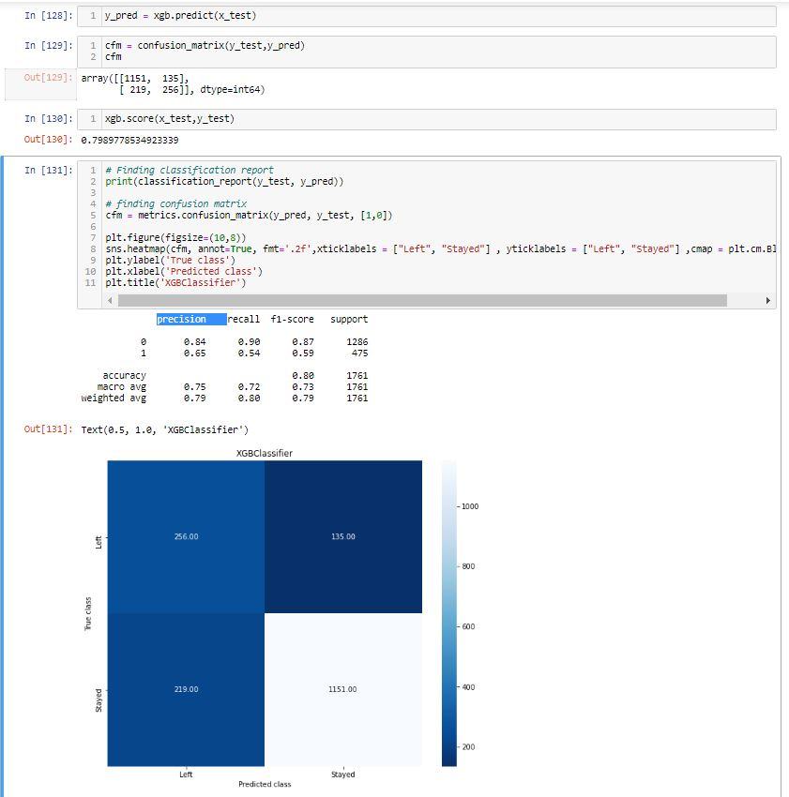

**By using Grid search CV in XGBoost Classifier I improve Accuracy Score to 79.89%**

**Roc Auc Score in** **XGBoost Classifier** *The AUC for the ROC can be calculated using the roc_auc_score() function , the AUC function takes both the true outcomes (0,1) from the test set and the predicted probabilities for the 1 class. It returns the AUC score between 0.0 and 1.0 for no skill and perfect skill respectively.*

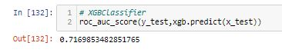

#### So, I get Auc Score from XGB classifier is 71.69%

**ADA BOOST**

*Adaptive Boosting, is a Boosting technique used as an Ensemble Method in*[*Machine Learning*](https://www.mygreatlearning.com/blog/what-is-machine-learning/)*. It is called Adaptive Boosting as the weights are re-assigned to each instance, with higher weights assigned to incorrectly classified instances AdaBoost can be used to boost the performance of any machine learning algorithm. It is best used with weak learners. These are models that achieve accuracy just above random chance on a classification problem.*

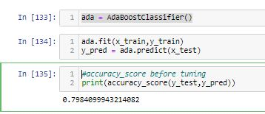

*By using ADA Boost Classifier I Get Accuracy Score : 79.84%. Now I have to improve the accuracy score by using best hyperparameters*

### **Let use Grid search CV for the best parameter to improve the accuracy.**

*GridSearchCV is a library function that is a member of sklearn's model_selection package. It helps to loop through predefined hyperparameters and fit your estimator (model) on your training set. So I used Grid search CV to choose the best parameters in this Adaptive Boosting algorithm.*

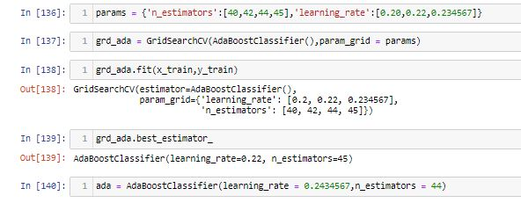

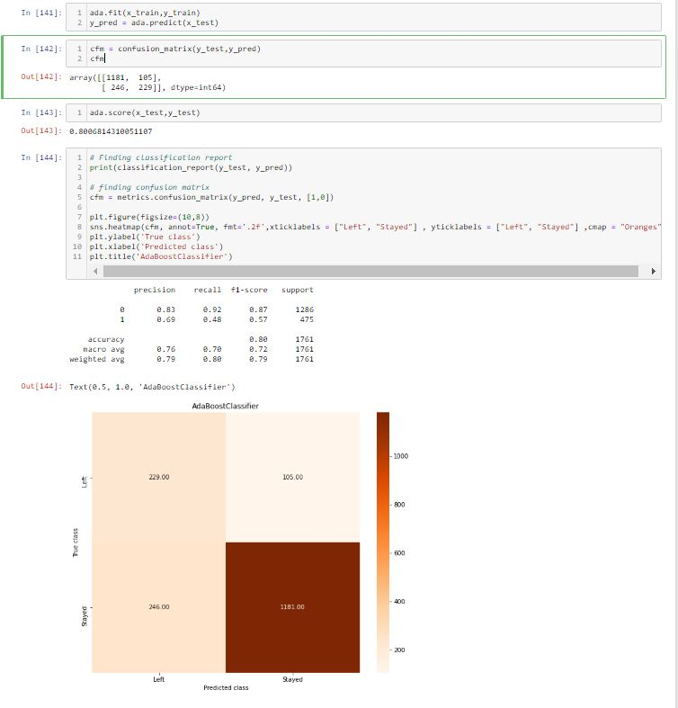

### **By using Grid Search CV In Adaptive Boosting Classifier improve the Accuracy Score to 80.06%**

**Roc Auc Score in** **Adaptive Boosting Classifier** *The AUC for the ROC can be calculated using the roc_auc_score() function , the AUC function takes both the true outcomes (0,1) from the test set and the predicted probabilities for the 1 class. It returns the AUC score between 0.0 and 1.0 for no skill and perfect skill respectively.*

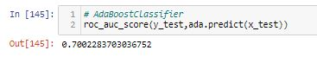

*So, I get Auc Score from Ada Boost classifier is 70.02%.*

## **Roc Curve**

*An ROC curve (receiver operating characteristic curve) is a graph showing the performance of a classification model at all classification thresholds. This curve plots two parameters: True Positive Rate. False Positive Rate. ROC is a probability curve, and AUC represents the degree or measure of separability. It tells how much model is capable of distinguishing between classes. Higher the AUC, better the model is at predicting 0s as 0s and 1s as 1s. By analogy, Higher the AUC, better the model is at distinguishing between customers will be churned or not churn.*

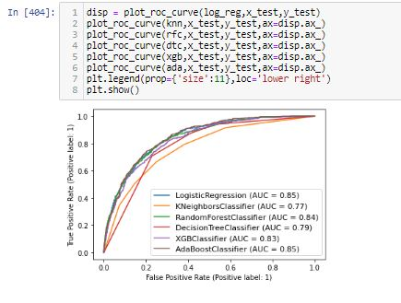

#### According to my Roc_Auc Curve I can say that Logistic Regression Model with 85% is the best predictive model in this dataset.

**Saving the Best Model**

*In machine learning I need to save the trained models in a file and restore them in order to reuse it to compare the model with other models, to test the model on a new data. I have use pickle method to save the best model in this dataset.*

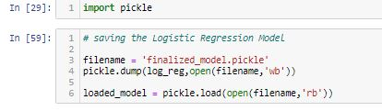

#### Saving Logistic Regression Model as it accuracy score is 80.12% and Roc_Auc Curve value is 85%

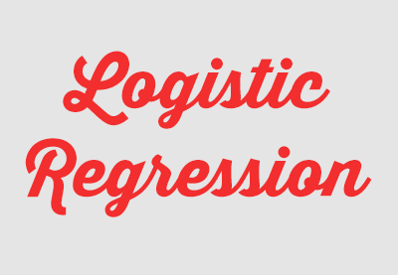

**Observation**

*I’ll briefly discuss how I approached this problem of predicting Churn.*

1. *I have Churn dataset from which I had to extract information.*

*b ) I had used pandas library to read the dataset which provide me to explore & visualize the data properly based on Rows & Columns.*

*c) I have pre-processed the data using replacing all zeros.*

*d) I did exploratory data analysis on main data frame and tried to see all visualizations.*

*e) Based on visualization knowledge, I used various EDA TECHNIQUES to plot the graphs and Box Plot.*

*f) I used VIF and Standard Scalar to scaled the data and by VIF I make a relationship between Features & Features.*

*g) I split the Features & Labels into 2 parts.*

*h) On this data, I have applied our machine learning models such as logistic regression, Random forest, KNN, XGBClassifier, Decision Tree Classifier and AdaBoostClassifier.*

*i) After which I found Logistic Regression has the highest accuracy score(80%) and best among all the models.*

*j)Based on the model scores, to predict customer churn Logistic Regression seems to be the best model for this dataset.*

**5.Conclusion**

*The importance of this type of research in the telecom market is to help companies make more profit. It has become known that predicting churn is one of the most important sources of income to telecom companies.*

*From the dataset I can say that out of every 4 customer 1 customer are likely to leave their existing internet service provider. I can also say that people don’t prefer to involve in contract so I can say that there is a trust issue as well involved.*

*I have applied feature engineering, effective feature transformation and selection approach to make the features ready for machine learning algorithms. In addition, I encountered another problem: the data was not balanced.*

*Six based algorithms were chosen because of their diversity and applicability in this type of prediction. These algorithms are Logistic Regression ,KNN, Decision Tree, Random Forest, ADA Boost algorithm, and XGBOOST algorithm.*

*The method of preparation and selection of features and entering the mobile social network features had the biggest impact on the success of this model, since the value of AUC in this dataset reached 80.12% Logistic Regression model achieved the best results in all measurements. The AUC value was 85%*

*Adaptive Boosting & Random Forest Classifier comes in the second place and the XGB Classifier i and Decision Tree & came third and fourth while KNN at last regarding AUC values.*

*The use of the Social Network Analysis features enhance the results of predicting the churn in telecom.*



**Links References**

*I have examined customer data from IBM Sample Data Sets with the aim of building and comparing several customer churn prediction models.*

*Dataset* *Link:*

[*https://github.com/dsrscientist/DSData/blob/master/Telecom_customer_churn.csv*](https://github.com/dsrscientist/DSData/blob/master/Telecom_customer_churn.csv)

*ipynb Link:*

[*https://github.com/krishnaprasad19960726/Evaluation-Project/blob/main/Customer%20Churn%20Analysis%20(3).ipynb*](https://github.com/krishnaprasad19960726/Evaluation-Project/blob/main/Customer%20Churn%20Analysis%20(3).ipynb)

**Thank you for reading!**

*If you enjoyed this article, check out my other articles on Data Science, Math and Programming. Follow me on GITHUB for the latest updates.*

*Thank you again for reading!*



--------------------------------------------------------xxxxxxxxxx---------------------------------------------------------------

**Blog Submission**

**Project - 2**

# Loan Application Status Prediction

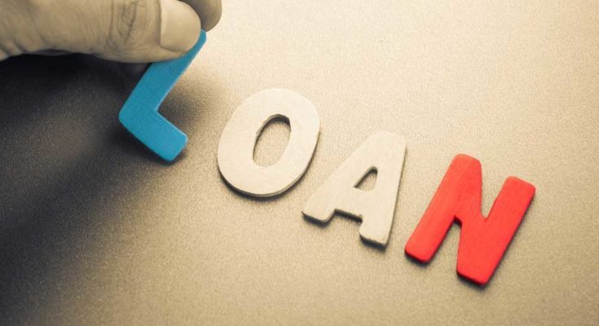

*This is my Second machine learning project. Recently I have completed this project. I am here to describe how i solved the case study in a very detailed manner.*

**Submitted by: Krishna Prasad**

**Acknowledgement**

*Many thanks to Data Trained for Providing me this project to understand about the Real Time Field work present in Data Science Industry.*

*As this project of Loan prediction was very sufficient and preferable for me to acknowledge about the live customers who are eligible for getting Loan or not.*

**Problem Statement**

*This dataset includes details of applicants who have applied for loan. The dataset includes details like credit history, loan amount, their income, dependents etc.*

**Independent Variables:**

**- Loan_ID**

**- Gender**

**- Married**

**- Dependents**

**- Education**

**- Self_Employed**

**- ApplicantIncome**

**- CoapplicantIncome**

**- Loan_Amount**

**- Loan_Amount_Term**

**- Credit History**

**- Property_Area**

**Dependent Variable (Target Variable):**

**- Loan_Status**

*I have to build a model that can predict whether the loan of the applicant will be approved or not on the basis of the details provided in the dataset.*

**TYPE OF PROBLEM**

*The above problem is a clear classification problem as we need to classify whether the Loan_Status is yes or no. So this can be solved by any of the classification techniques like:*

1. ***Logistic Regression***
2. ***Decision Tree Algorithm***
3. ***Random Forest Technique***
4. ***Decision Tree***

*I have mentioned only few. I will be dealing with each of techniques later in this blog.*

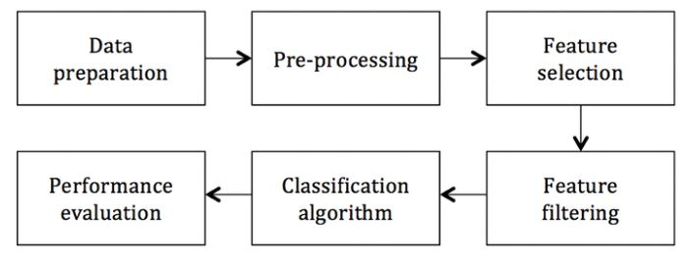

**Introduction**



*A loan is when you receive money from a friend, bank or financial institution in exchange for future repayment of the principal, plus interest. The principal is the amount you borrowed, and the interest is the amount charged for receiving the loan. Since lenders are taking a risk that you may not repay the loan, they have to offset that risk by charging a fee known as interest.*

*Financial companies have been using predictive analytics for quite a long time.*

*Recently, due to the availability of computational resources and tremendous research in machine learning made it possible to better data analysis hence better prediction. In the series of articles, I explain how to create a predictive loan model that identifies a bad applicant who is more likely to be charged off. In a step by step processes, I show how to process raw data, clean unnecessary part of it, select relevant features, perform exploratory data analysis, and finally build a model****.***

**Label:**

*In this project my goal is to Predict the loan Status and has to estimate the risk involved before granting a loan to a customer.*

**Description about the Data Columns**

*There are altogether 13 columns in our data set. Of them Loan Status is the response variable and rest all are the variables /factors that decide the approval of the loan or not. Now let us look in to the each variable and can make some assumptions.*

*Loan ID -> As the name suggests each person should have a unique loan ID.*

*Gender -> In general it is male or female. No offence for not including the third gender.*

*Married -> Applicant who is married is represented by Y and not married is represented as N.*

*The information regarding whether the applicant who is married is divorced or not has not been provided. So we don’t need to worry regarding all these.*

*Dependents -> the number of people dependent on the applicant who has taken loan has been provided.*

*Education -> It is either non -graduate or graduate. The assumption I can make is “ The probability of clearing the loan amount would be higher if the applicant is a graduate”.*

*Self_Employed -> As the name suggests Self Employed means , he/she is employed for himself/herself only. An applicant who is self employed is represented by Y and the one who is not is represented by N.*

*Applicant Income -> Applicant Income suggests the income by Applicant. So the general assumption that i can say that “The one who earns more have a high probability of paying loan amount and would be highly eligible for loan ”*

*Co Applicant income -> This represents the income of co-applicant. can also assume that “ If co applicant income is higher , the probability of being eligible would be higher “*

*Loan Amount -> This amount represents the loan amount in thousands. One assumption I can make is that “ If Loan amount is higher , the probability of repaying would be lesser and vice versa”.*

*Loan_Amount_Term -> This represents the number of months required to repay the loan.*

*Credit_History -> When I googled it , I got this information. A credit history is a record of a borrower’s responsible repayment of debts. It suggests → 1 denotes that the credit history is good and 0 otherwise.*

*Property_Area -> The area where they belong to is my general assumption as nothing more is told. Here it can be three types. Urban or Semi Urban or Rural*

*Loan_Status -> If the applicant is eligible for loan it’s yes represented by Y else it’s no represented by N.*

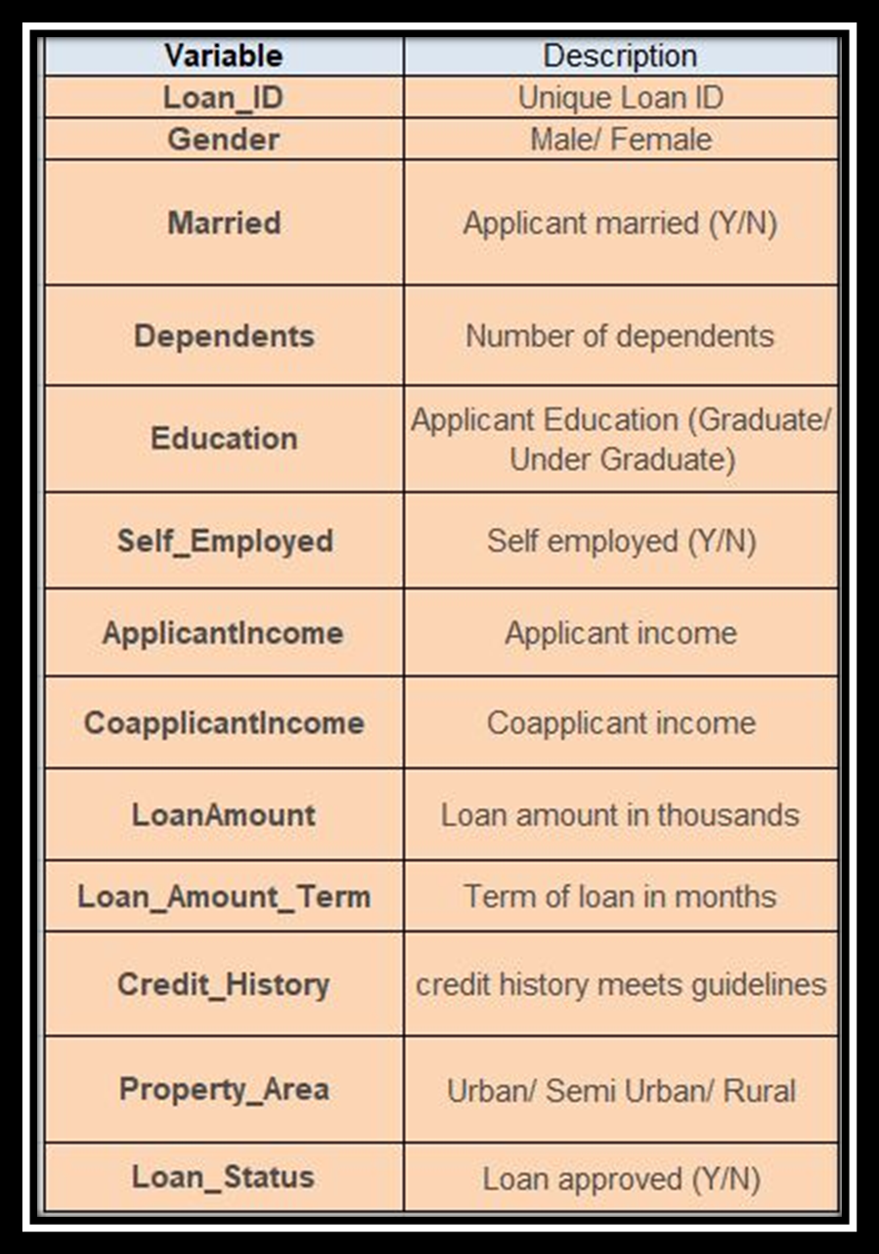

**Importing Libraries**

*I am importing all the library which I required for EDA, visualization, prediction and finding all matrices. The reason of doing this is that it become easier to use all the import statement at one go and we do not require to import the statement again at each point.*

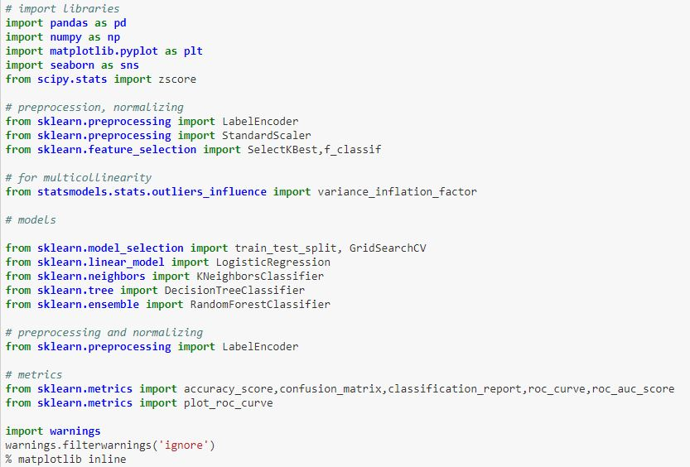

**Loading Data Set into variable**

*Here I am loading the data set into a variable i.e. “df” and processing the first 5 rows.*

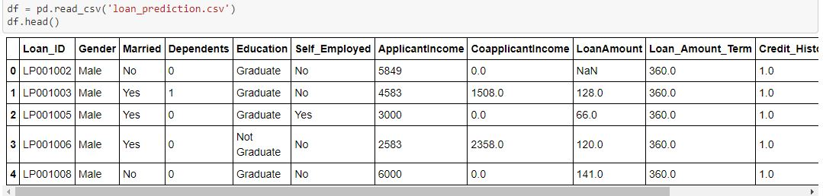

**3.Exploratory Data Analysis**

*Exploratory Data Analysis (EDA) ensures the readiness of the data for Machine Learning. In fact, EDA is primarily used to see what data can reveal beyond the formal modelling or hypothesis testing task and provides a provides a better understanding of data set variables and the relationships between them.*

*By looking at the columns description in the above paragraph, i can make many assumptions like : 1. The one whose salary is more can have a greater chance of loan approval.*

*2. The one who is graduate has a better chance of loan approval.*

*3. Married people would have a upper hand than unmarried people for loan approval .*

*4. The applicant who has less number of dependents have a high probability for loan approval.*

*5. The lesser the loan amount the higher the chance for getting loan.*

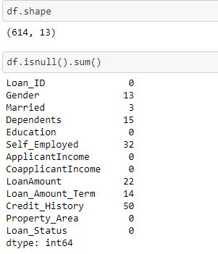

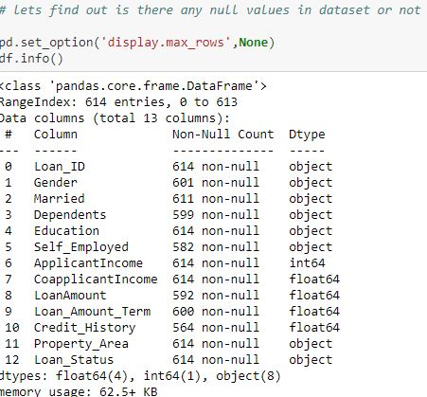

***There are 614 rows and 13 columns in the dataset. There are null values in few columns which I will fixed it soon.***

**Checking duplicates**

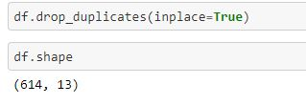

***There are no duplicates values in the dataset.***

**Identifying the columns**

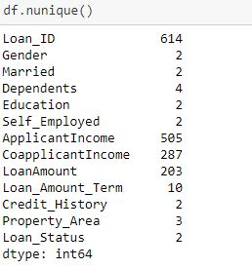

***It is a mixed dataset as it contains few columns which are categorical in nature and few are continuous in nature.***

**Describing the columns**

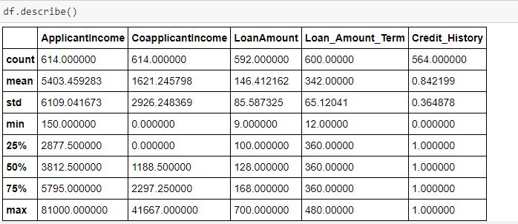

*Above statistics data show that there multiple outliers mostly in Applicant Income. There is also difference between mean and 50% value in some of the columns which used to get fix for better prediction.*

*Also, number of rows in each column are not same, means there are null values in the data set.*

*Also, the mean and 50%value of most of the column are not same and the STD and mean have a major difference to each other.*

*Most of the columns of min value are near to 0 values.*

*By checking the difference between the 75% and max value there are outliers in some of the column, I will check it soon.*

***Count Plot & Pie Plot Definition***

***Count Plot***

*Count Plot function is used for visualizing data of a machine learning and data science project. The Count Plot is majorly used for showing the observational count in different category based bins with the help of bars.*

**Making Plots of Categorical Columns**

**Loan status**

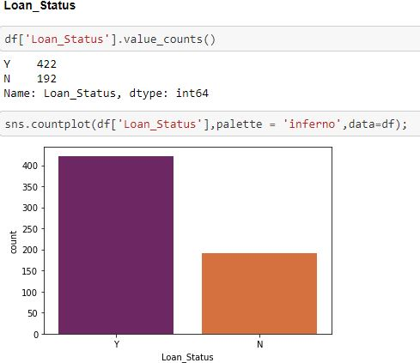

***According to the Count Plot of "Loan_Status" column i can see "Y" shows the Approval and "N" give Disapproval of Loan in the Dataset. There are 422 approved loan and 192 loan not approved. It is balanced dataset.***

**Gender**

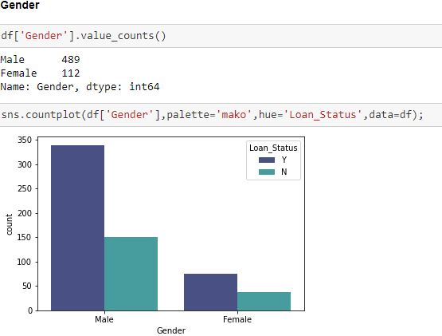

***There are 489 males applied for the loan and 112 female applied for the loan. I can say that both male and female loan rejection status are in same ratio.***

**Married**

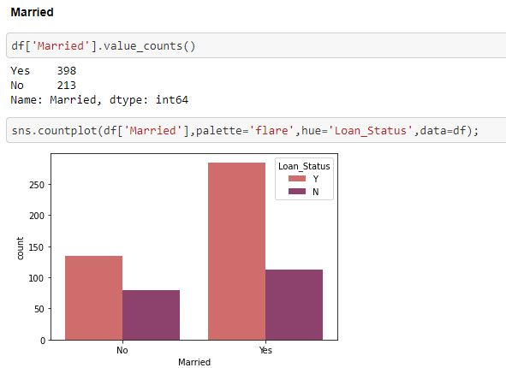

***There are 398 people applied for the loan are married and 213 are unmarried. From the graph I can say that those who are unmarried are more in numbers in terms of loan rejection than those who are married.*** *In short I can say that Married Couples have a higher opportunity of Getting Loan rather than Unmarried ones****.***

**Dependents**

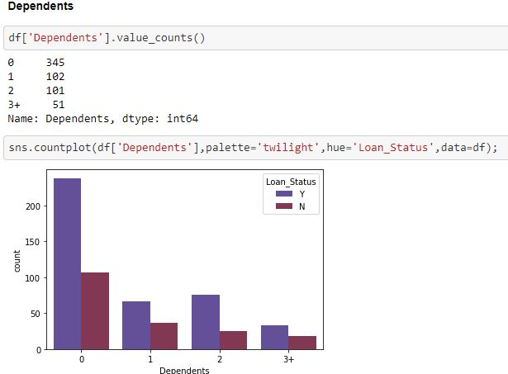

***I can say that those people who have no dependent are getting there loan approved easily as compared to those who have more than 1 family members as a dependent. I can say the loan rejection chances is high those people who have 3+ members as dependent.***

**Education**

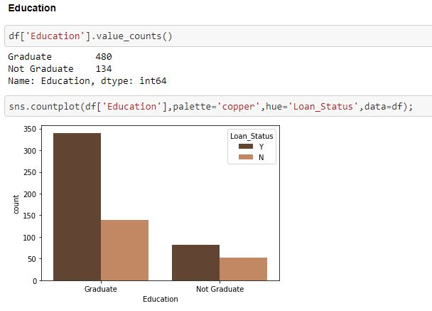

***Education graph Shows that there are more number of graduates than non-graduates in this dataset. There are 480 graduates and 134 under graduates applied for the loan. Moreover people who are not graduates are less in numbers as compared to those who are graduates in terms of approved loan.***

**Self_Employed**

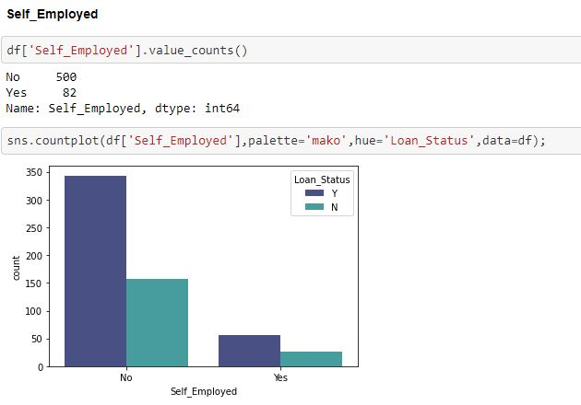

***There are only 82 people in the dataset who are self employed and 500 people are not self-employed. So, from this graph I can say that those who are salaried people they have more loan requirements as compared to self-employed.***

**Loan_Amount_Term**

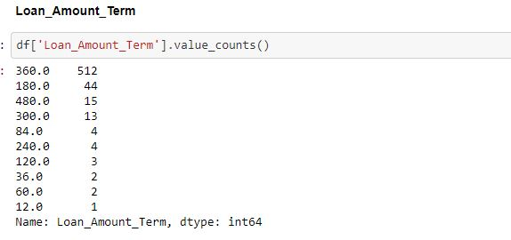

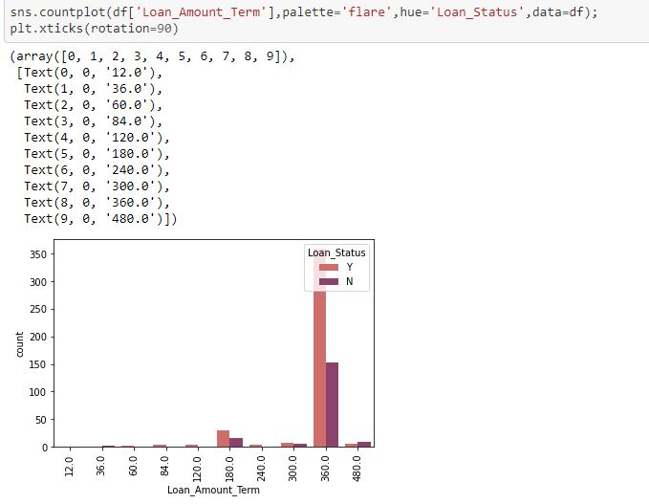

***I can say that maximum people have applied for loan for the 360-month terms. Which means they are going to replay the loan on EMI basis for 3 years.***

**Credit_History**

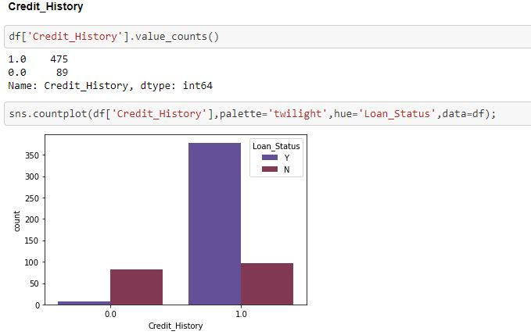

*In the above plot i can say that Larger Percentage of people have a good credit history. 0 represent poor credit history which means their loan rejection chances are very high.*

**Property_Area**

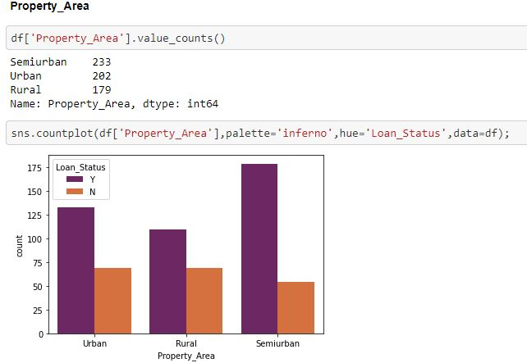

***From the above count plot i can see that Semi-Urban peoples required Loan more than the remaining Urban & Rural Property Areas people. I can say that the loan rejection chances is more in rural area than urban and semi urban. This might be situation because rural people have less source of income so loan rejection chance is high.***

**Filling the missing values**

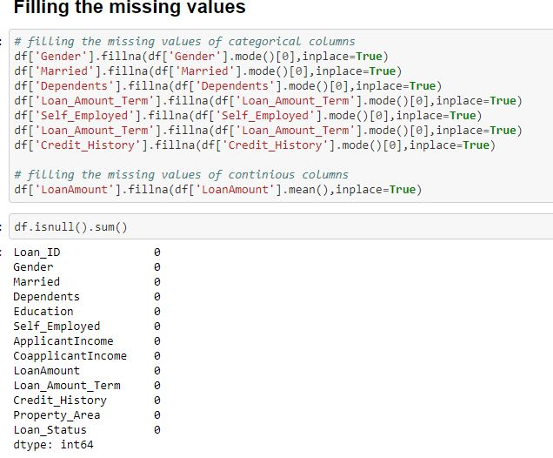

*There were few null values in the dataset which I have removed with the fillna command. Continuous column is filled with mean & Categorical Column is Filled with mode.*

**Replacing Categorical columns into numerical values**

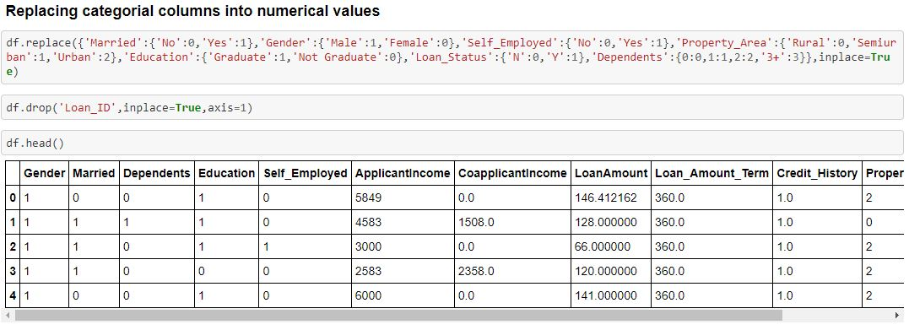

*I have converted all the string columns to numerical values for best prediction and visualization.*

**Distribution Plot**

*It is used basically for univariate set of observations and visualizes it through a histogram that is only one observation and hence we choose one particular column of the dataset.*

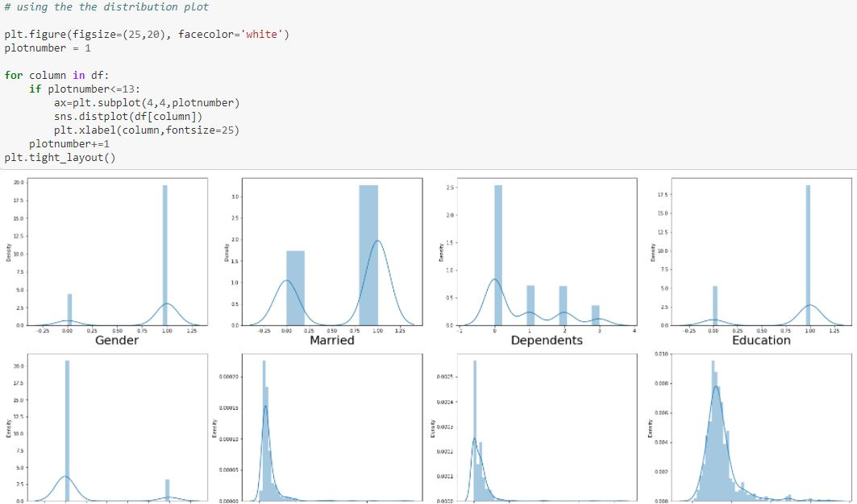

*I have plot distribution plot to check the skewness of the dataset. There is skewness in few columns which I will get it fixed soon.*

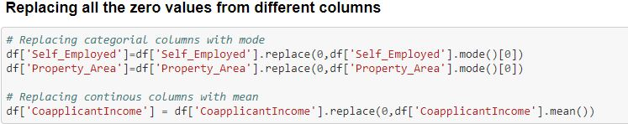

***According to the Dataset these 3 columns (Self_Employed, Property_Area, CoapplicantIncome) have zero values which i have replace it with the help of mean and mode.***

**Box Plot**

#### **Box** **Plot** is the visual representation of the depicting groups of numerical data through their quartiles. **Boxplot** is also used for detect the outlier in data set.

*I used box plot in this dataset because It captures the summary of the data efficiently with a simple box and whiskers and allows me to compare easily across groups.*

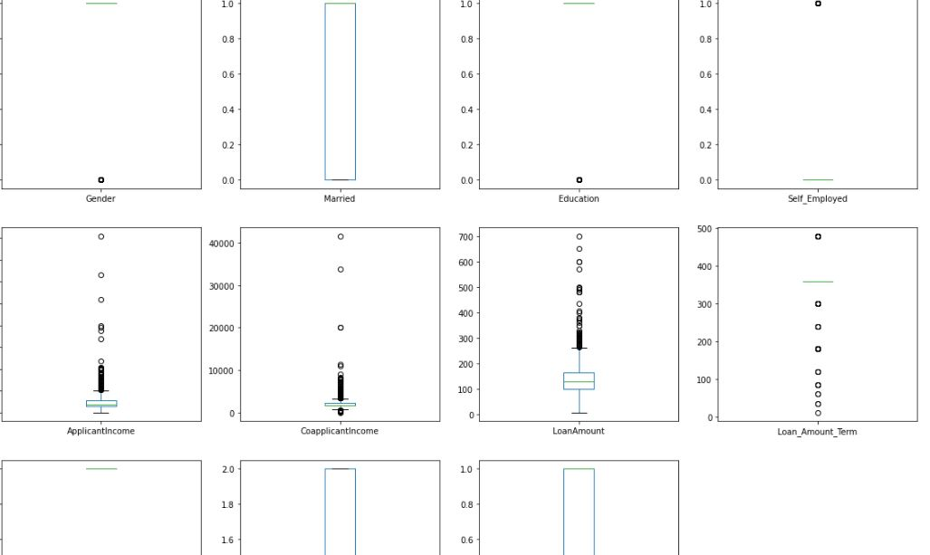

***From above image we can clear see that there are number of black dots in most of the column which are referring to the outliers, so it means most of the columns have outliers.***

**ZScore**

*Z score is also called standard score. This score helps to understand if a data value is greater or smaller than mean and how far away it is from the mean. More specifically, Z score tells how many standard deviations away a data point is from the mean.*

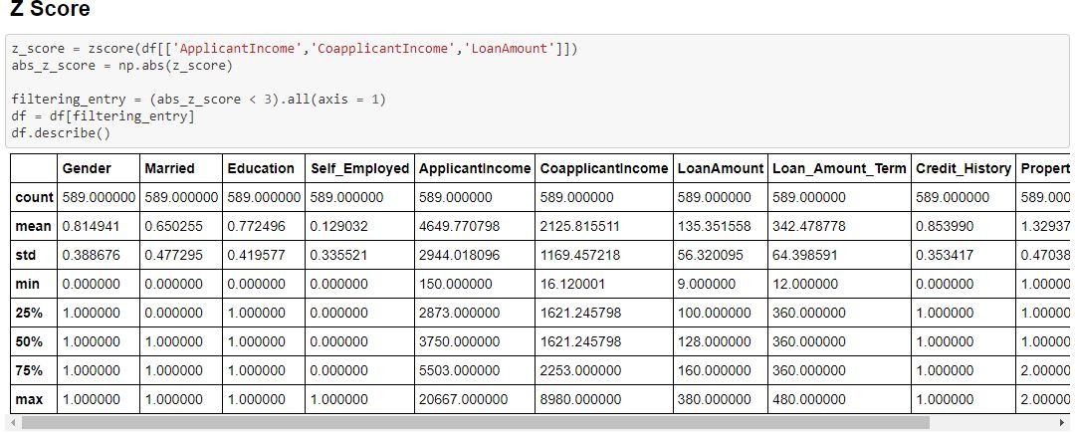

***So now we detect the outliers now the second step is to remove the outliers, there are different way to remove the outliers i will be using z score above to remove outliers.***

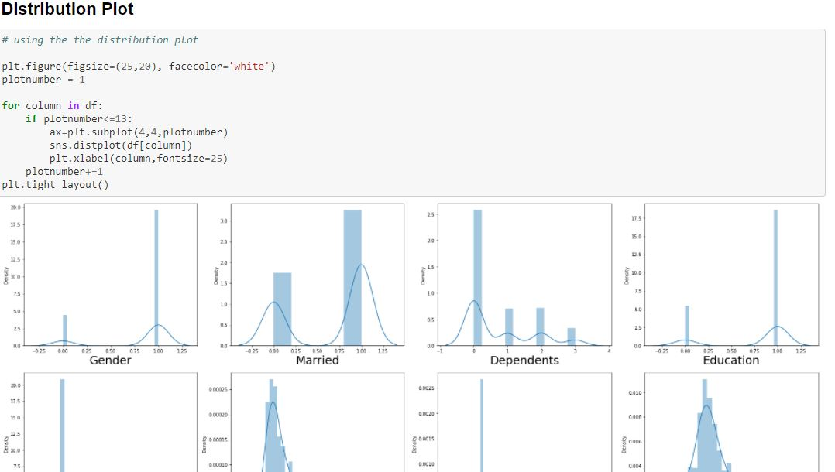

***After Removing Outliers & Skewness I make Distribution Plot to understand how much my data is ready for Model Prediction.***

[**4.Building Machine Learning Models**](https://towardsdatascience.com/building-an-employee-churn-model-in-python-to-develop-a-strategic-retention-plan-57d5bd882c2d#8341)

*Here's the role of the label that comes into existence. A label is given to such features to distinguish them from other features. Thus, I have obtain labels as output when provided with features as input*.

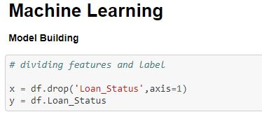

*Dividing the features and label into x and y.*

**STANDARD SCALER**

*In Machine Learning, Standard Scaler is used to resize the distribution of values ​​so that the mean of the observed values ​​is 0 and the standard deviation is 1.*

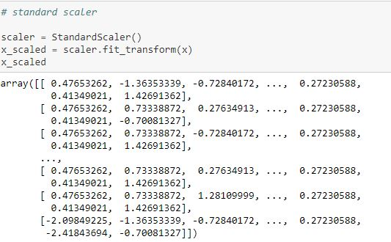

#### By using standard scaler, I have scaled the data in one range.

**VIF – VARIANCE INFLATION FACTOR**

*VIF is preferred as it can ‘****show the correlation of a variable with a group of other variables’****. Dropping one of the correlated features will help in bringing down the multicollinearity between correlated features: The image contains the original VIF value for the dataset.*

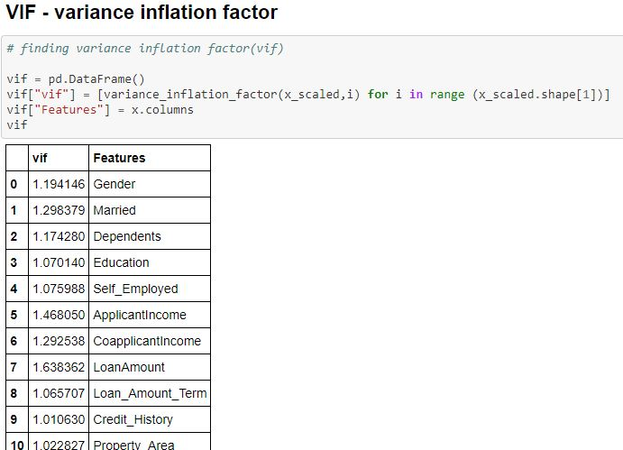

# *VIF score for all the columns is below 5 which means Multicollinearity doesn’t exist.*

# *Train Test Split*

# *The train-test split procedure is used to estimate the performance of machine learning algorithms when they are used to make predictions on data not used to train the model.*

# *I used train test split as it is a fast and easy procedure to perform, the results of which allow me to compare the performance of machine learning algorithms for my predictive modelling problem.*

# 

#### Therefore, I have split the dataset into training and testing. I have used 25% of data for testing and 75% of the dataset for training. I used random state for consistent result.

**LOGISTIC REGRESSION**

*Logistic regression is a supervised learning classification algorithm used to predict the probability of a target variable. The nature of target or dependent variable is discontinuous ,which means there would be only two possible classes.*

*Generally, logistic regression means binary logistic regression having binary target variables, but there can be two more categories of target variables that can be predicted by it.*

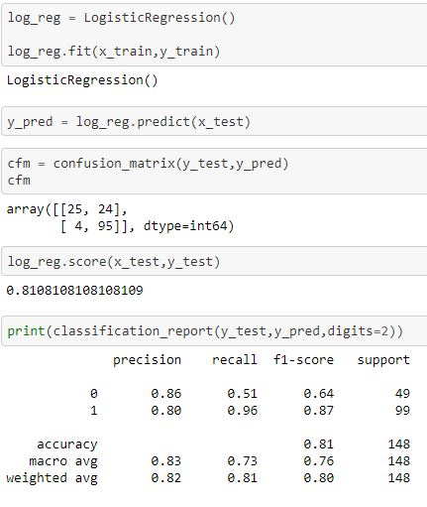

#### So, I get Auc Score from Logistic Regression is 81.08%.

**AUC SCORE**

*The AUC for the ROC can be calculated using the roc_auc_score() function , the AUC function takes both the true outcomes (0,1) from the test set and the predicted probabilities for the 1 class. It returns the AUC score between 0.0 and 1.0 for no skill and perfect skill respectively.*

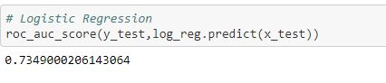 So, I get Auc Score from Logistic Regression is 73.49%.

**KNN**

**Features Selection Method**

*Feature Selection is one of the core concepts in machine learning which hugely impacts the performance of your model. The data features that you use to train your machine learning models have a huge influence on the performance you can achieve.*

*Irrelevant or partially relevant features can negatively impact model performance.*

*Feature selection and Data cleaning should be the first and most important step of your model designing. Therefore, I used Select K Best Method for best features selection.*

### **Using SelectKBest Method for best features selection**

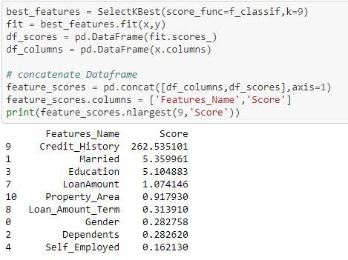

*According to the SelectKBest Method Credit_History plays an important role in Approving loans to the ultimate individuals.*

**KNN - K-Nearest Neighbour**

*It is a supervised machine learning algorithm. The algorithm can be used to solve both classification and regression problem statements. The KNN algorithm can compete with the most accurate models because it makes highly accurate predictions. Therefore, you can use the KNN algorithm for applications that require high accuracy but that do not require a human-readable model. The quality of the predictions depends on the distance measure.*

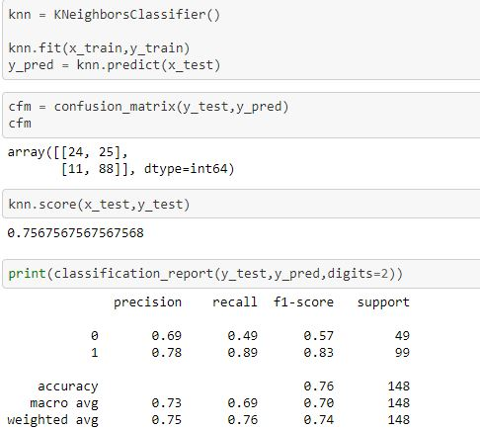

*By using KNN I Get Accuracy Score : 76%.*

# Let use Grid search CV for the best parameter to improve the accuracy

# *GridSearchCV is a library function that is a member of sklearn's model_selection package. It helps to loop through predefined hyperparameters and fit your estimator (model) on your training set. So, in the end, you can select the best parameters from the listed hyperparameters. So I used Grid search CV to choose the best parameters in this knn algorithm*

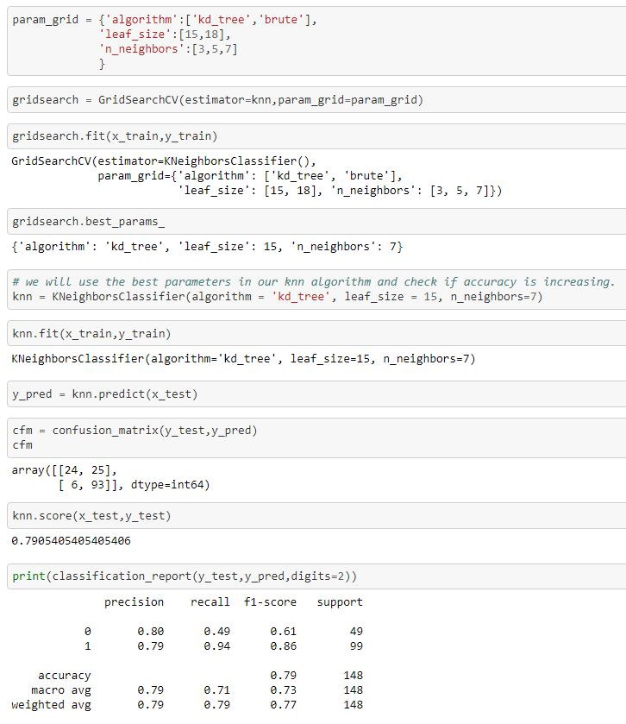

**By using Grid search CV in KNN I improve Accuracy Score : 79%**

**Auc Score of KNN**

*The AUC for the ROC can be calculated using the roc_auc_score() function , the AUC function takes both the true outcomes (0,1) from the test set and the predicted probabilities for the 1 class. It returns the AUC score between 0.0 and 1.0 for no skill and perfect skill respectively.*

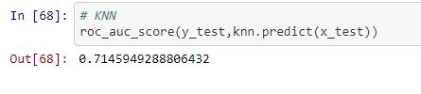

*So, I get Auc Score from KNN is 71.45%.*

**Random Forest Classifier**

*A random forest is a machine learning technique that's used to solve regression and classification problems. It utilizes ensemble learning, which is a technique that combines many classifiers to provide solutions to complex problems. So I have used 3rd algorithm Random Forest Classifier to predict the model.*

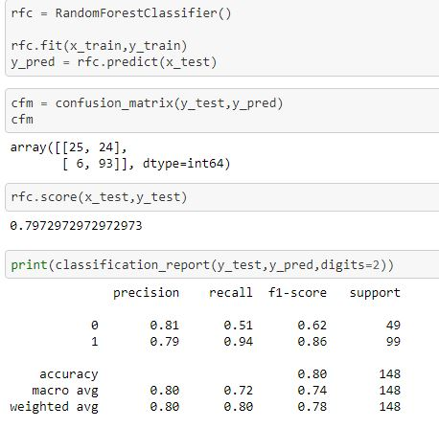

*By using Random Forest Classifier I Get Accuracy Score : 80%.*

**Let use Grid search CV for the best parameter to improve the accuracy**

*GridSearchCV is a library function that is a member of sklearn's model_selection package. It helps to loop through predefined hyperparameters and fit your estimator (model) on your training set. So**I used Grid search CV to choose the best parameters in this random forest algorithm.*

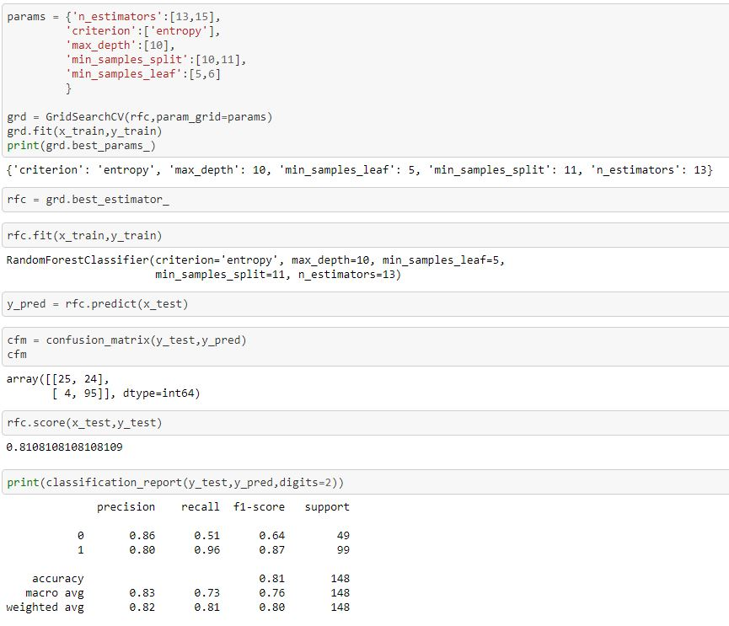

**By using Grid search CV in random forest I improve Accuracy Score to 81%**

**Auc Score of Random Forest classifier**

*The AUC for the ROC can be calculated using the roc_auc_score() function , the AUC function takes both the true outcomes (0,1) from the test set and the predicted probabilities for the 1 class. It returns the AUC score between 0.0 and 1.0 for no skill and perfect skill respectively.*

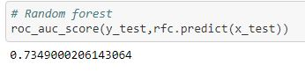

*So, I get Auc Score from Random Forest classifier is 73.49%.*

**Decision Tree Classifier**

*Decision tree is one of the predictive modelling approaches used in Machine Learning. It is one of the most widely used and practical methods for supervised learning. The decision tree Algorithm belongs to the family of supervised machine learning algorithms. It can be used for both a classification problem as well as for regression problem.* *Therefore Decision tree is the 4th Algorithm used by me.*

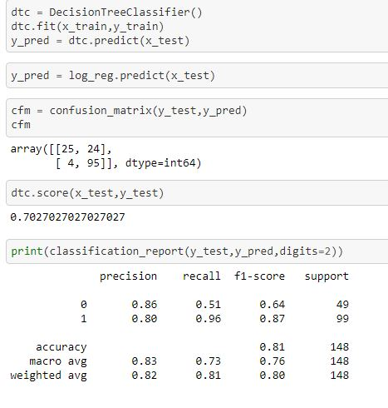

*By using Decision Tree Classifier I Get Accuracy Score : 81%*. *Now I have to improve the accuracy score by using best hyperparameters.*

**Let use Grid search CV for the best parameter to improve the accuracy.**

*GridSearchCV is a library function that is a member of sklearn's model_selection package. It helps to loop through predefined hyperparameters and fit your estimator (model) on your training set. So I used Grid search CV to choose the best parameters in this Decision tree algorithm.*

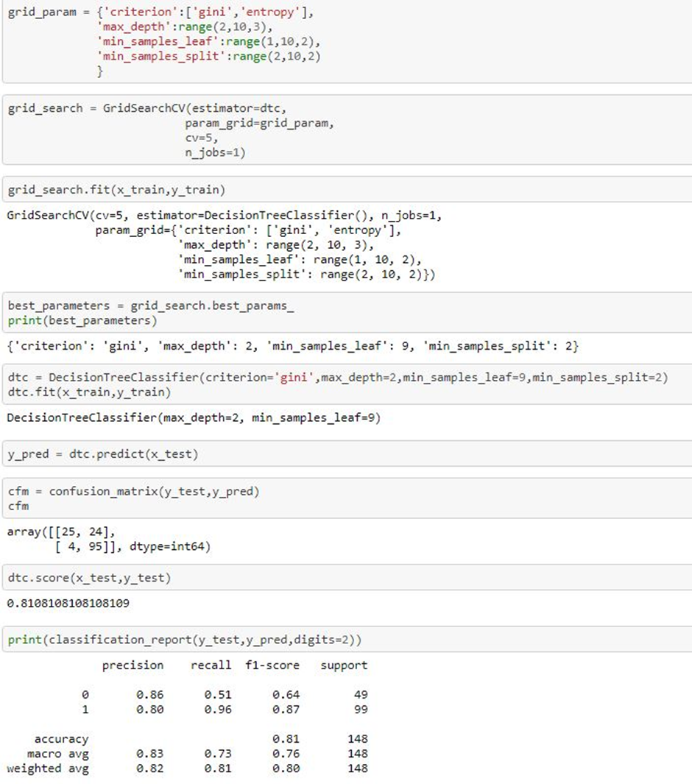

**By using Grid search CV in Decision tree has no improve in Accuracy Score to 81%**

**Auc Score in Decision tree Classifier** *The AUC for the ROC can be calculated using the roc_auc_score() function , the AUC function takes both the true outcomes (0,1) from the test set and the predicted probabilities for the 1 class. It returns the AUC score between 0.0 and 1.0 for no skill and perfect skill respectively.*

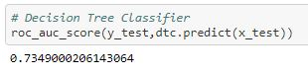

*So, I get Auc Score from Decision Tree classifier is 73.49%.*

**Roc Curve**

*An ROC curve (receiver operating characteristic curve) is a graph showing the performance of a classification model at all classification thresholds. This curve plots two parameters: True Positive Rate & False Positive Rate. ROC is a probability curve, and AUC represents the degree or measure of separability. It tells how much model is capable of distinguishing between classes. Higher the AUC, better the model is at predicting 0s as 0s and 1s as 1s. By analogy Higher the AUC, better the model is at distinguishing between individuals and Loan amount whether to approve the loan or n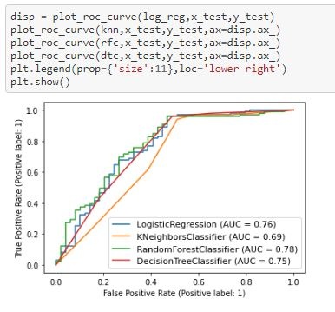.*

*According to my Roc_Auc Curve I can say that Random Forest Model with 81% is the best predictive model in this dataset.*

**Saving the Best Model**

*In machine learning I need to save the trained models in a file and restore them in order to reuse it to compare the model with other models, to test the model on a new data. I have use pickle method to save the best model in this dataset.*

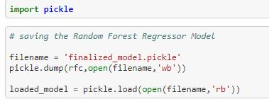

*Saving Random forest Model as it accuracy score is 81.08% and Roc_Auc Curve value is 73.49%.*



**Observation**

*I’ll briefly discuss how I approached this problem of predicting Churn.*

1. *I have Loan_Prediction dataset from which I had to extract information.*

*b ) I had used pandas library to read the dataset which provide me to explore & visualize the data properly based on Rows & Columns.*

*c) I have pre-processed the data using replacing all zeros.*

*d) I did exploratory data analysis on main data frame and tried to see all visualizations.*

*e) Based on visualization knowledge, I used various EDA TECHNIQUES to plot the graphs and Box Plot.*

*f) I used VIF and Standard Scalar to scaled the data and by VIF I make a relationship between Features & Features.*

*g) I split the Features & Labels into 2 parts.*

*h) On this data, I have applied our machine learning models such as logistic regression,* *Random forest, KNN, and Decision Tree Classifier .*

*i) After which I found Random forest has the highest accuracy score(81.08%) and best among l the models.*

*j)Based on the model scores, to predict Loan_Status Random forest seems to be the best model for this dataset.*

# Conclusion

# *In this article, I worked on the Loan Prediction dataset and analysed each feature one-by-one. Finally, I applied various Machine Learning models to learn from the data and make predictions.*

*I have gone through a good portion of the data science pipe line in this article, namely EDA , pre processing and modelling and we’ve used essential classification models such as Logistic regression , Decision tree, KNN and Random forests.*

*I have applied feature engineering, effective feature transformation and selection approach to make the features ready for machine learning algorithms.*

*Six based algorithms were chosen because of their diversity and applicability in this type of prediction. These algorithms are Logistic Regression ,KNN, Decision Tree and Random Forest, algorithm.*

*The method of preparation and selection of features and entering the mobile social network features had the biggest impact on the success of this model, since the value of AUC in this dataset reached 81.08% Random Forest model achieved the best results in all measurements. The AUC value was 73.49%.*

*By using similar methodology for the above classification problem I successfully completed this Loan Prediction Project.*

**Links References**

I have build a model that has predict whether the loan of the applicant will be approved or not on the basis of the details provided in the dataset.

**Dataset Link**

[**https://github.com/dsrscientist/DSData/blob/master/loan_prediction.csv**](https://github.com/dsrscientist/DSData/blob/master/loan_prediction.csv)

**Github Link**

[**https://github.com/krishnaprasad19960726/Evaluation-Project/blob/main/LOAN%20APPLICATION%20STATUS%20PREDICTION.ipynb**](https://github.com/krishnaprasad19960726/Evaluation-Project/blob/main/LOAN%20APPLICATION%20STATUS%20PREDICTION.ipynb)

**Thank you for reading!**

*If you enjoyed this article, Follow me on GITHUB for the latest updates.*

*Thank you again for reading!*

